**DJANGO**

**1. Install of Python**

https://www.python.org/downloads/

**2. Installation of PyCharm**

https://www.jetbrains.com/pycharm/download/#section=windows

# IDE: PyCharm

# Help (Menu) -> **About**

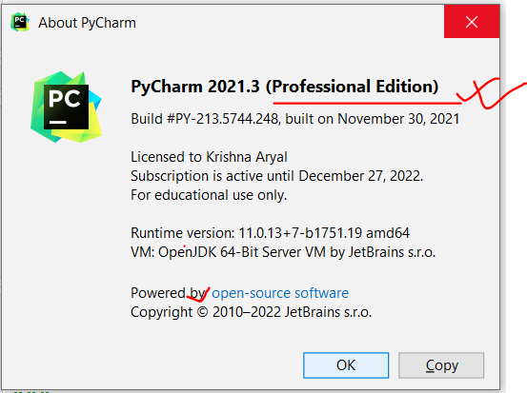

**3. Creating new Project (Django Project -> Website)**

* **File** (Menu) > **New Project**

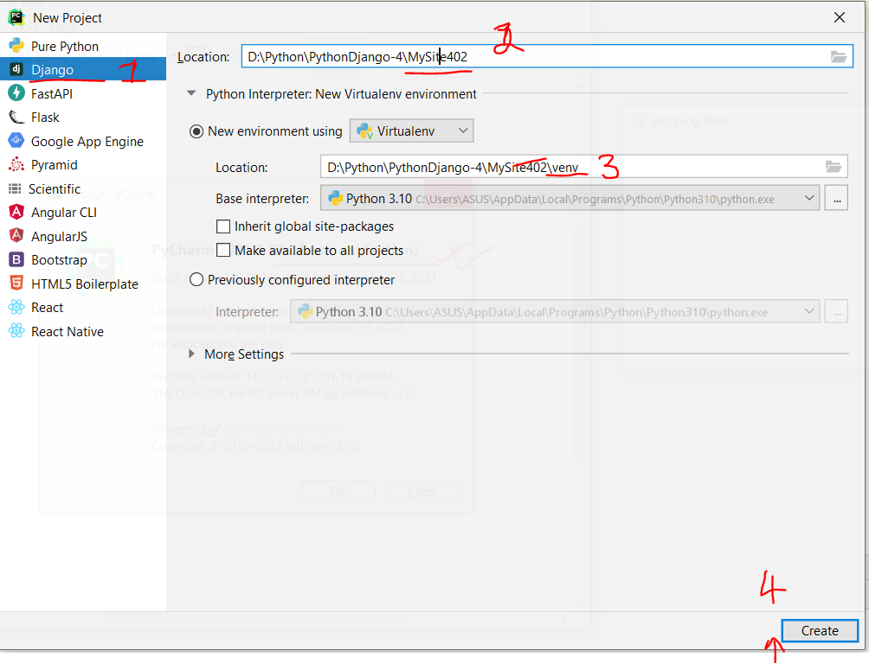

* Click on **Create** button

**4. Explore Django Project**

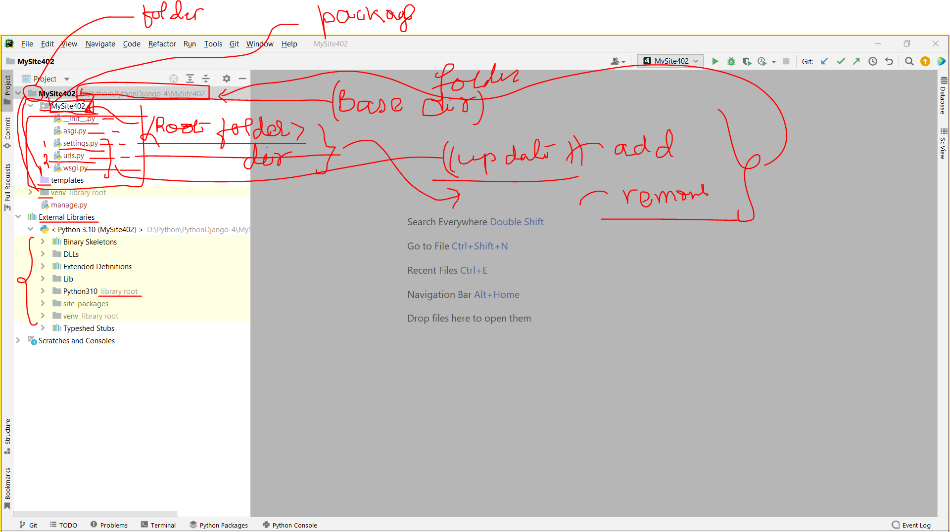

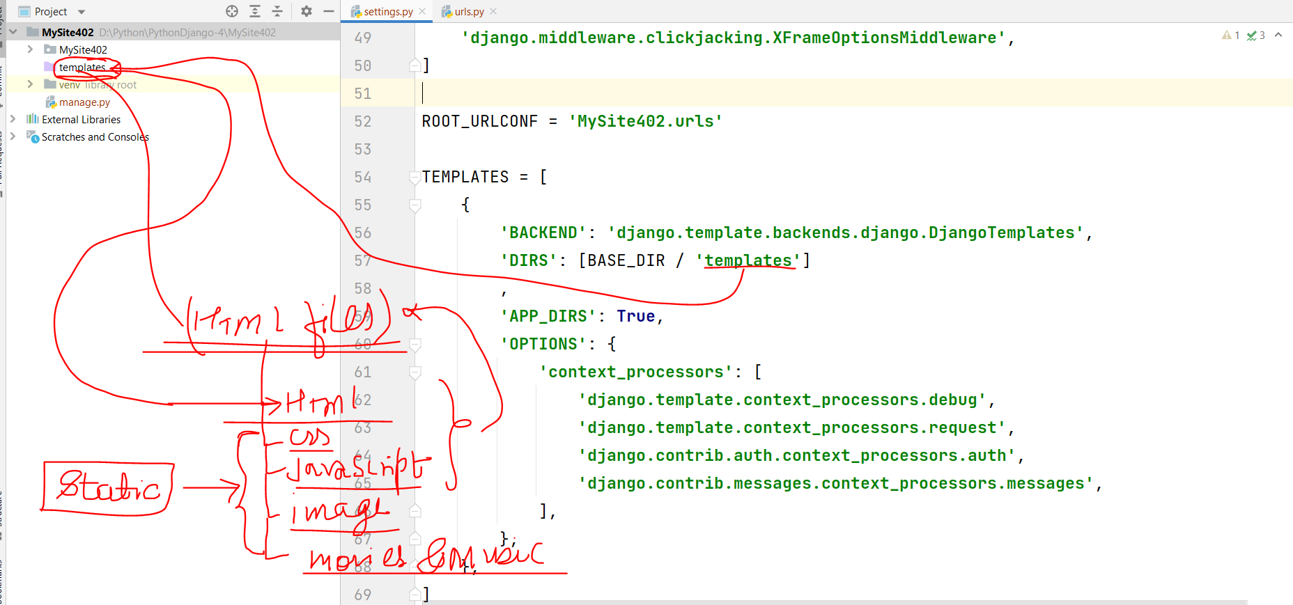

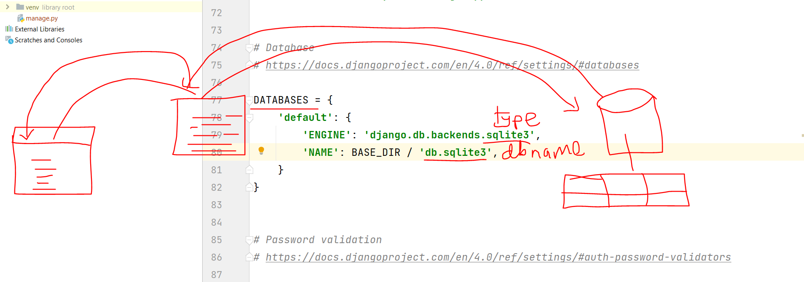

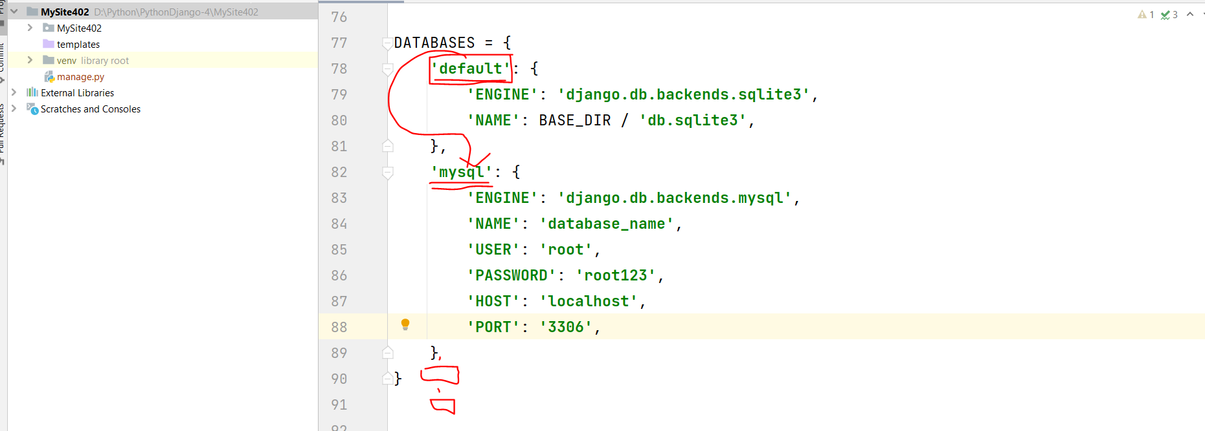

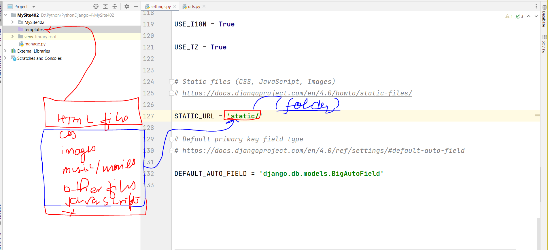

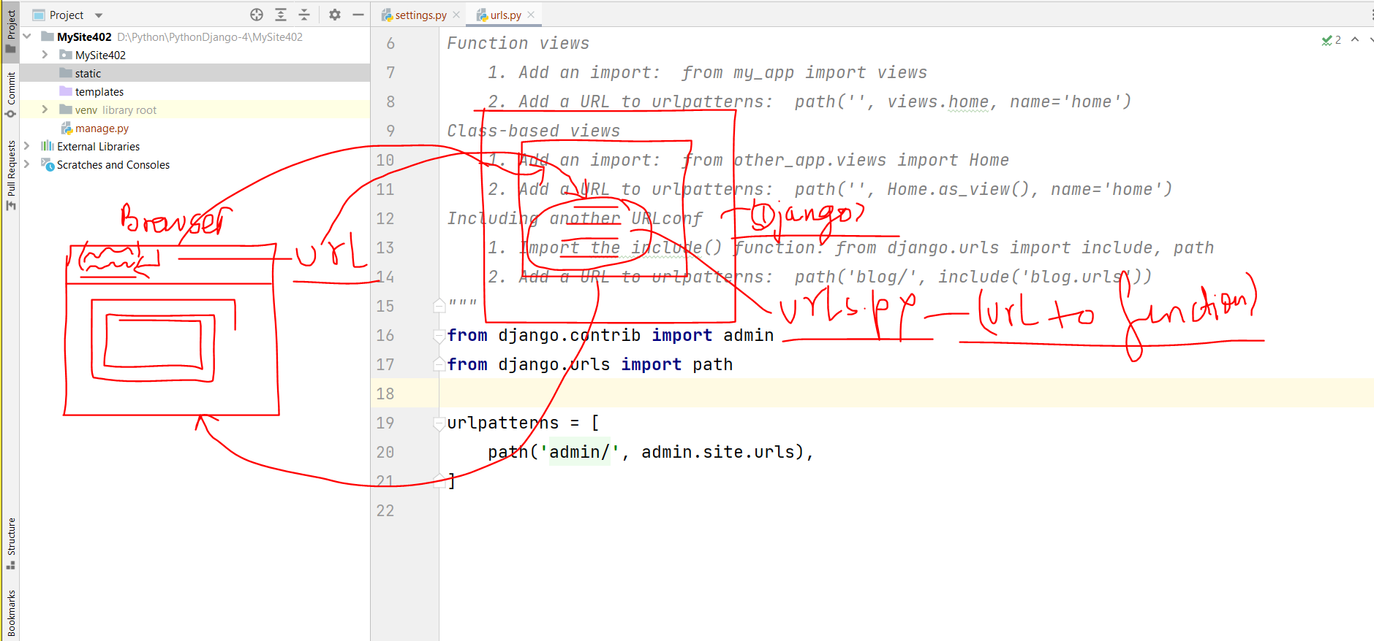

**settings.py**

**Testing/development**

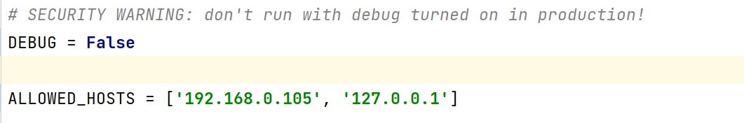

**Production/live site**

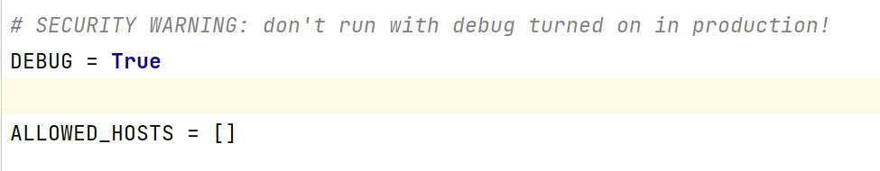

**Terminal > ipconfig/all**

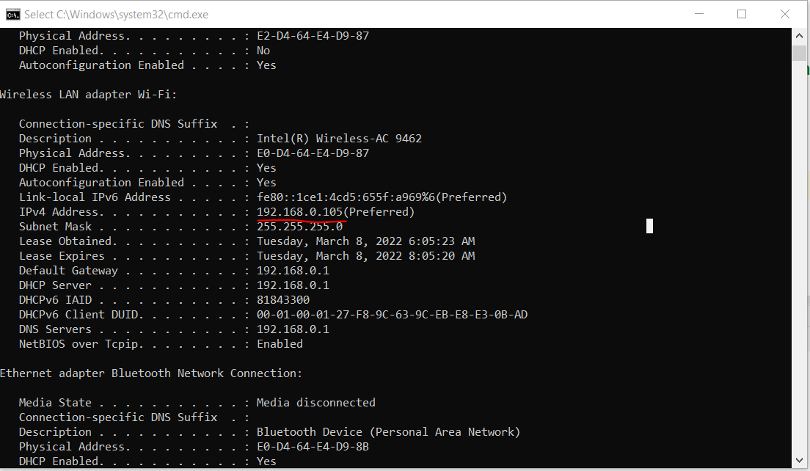

**5. Startring website (Up)**

**a.** Terminal **->** python manage.py **runserver**

**or**

b. Tools (Menu) -> **Run manage.py Task (Terminal of manage.py)**

**runserver**

**6. Website stop (down)**

Ctrl + Z or Ctrl + C

**7. Browse the website**

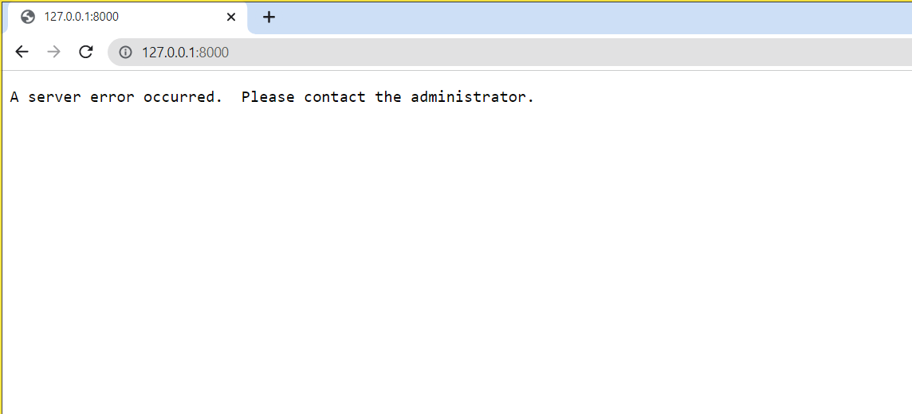

**8. Port in Server Start**

**General Terminal Command**

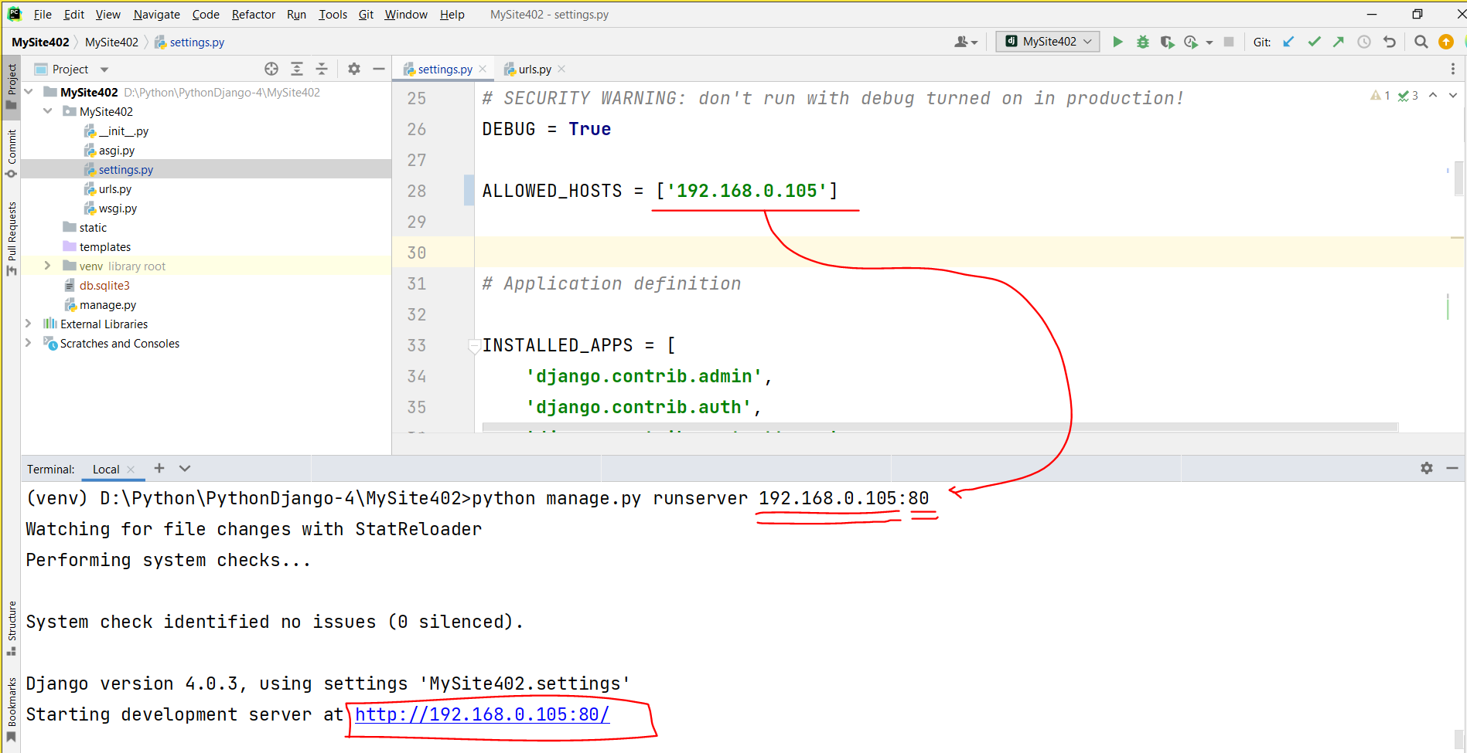

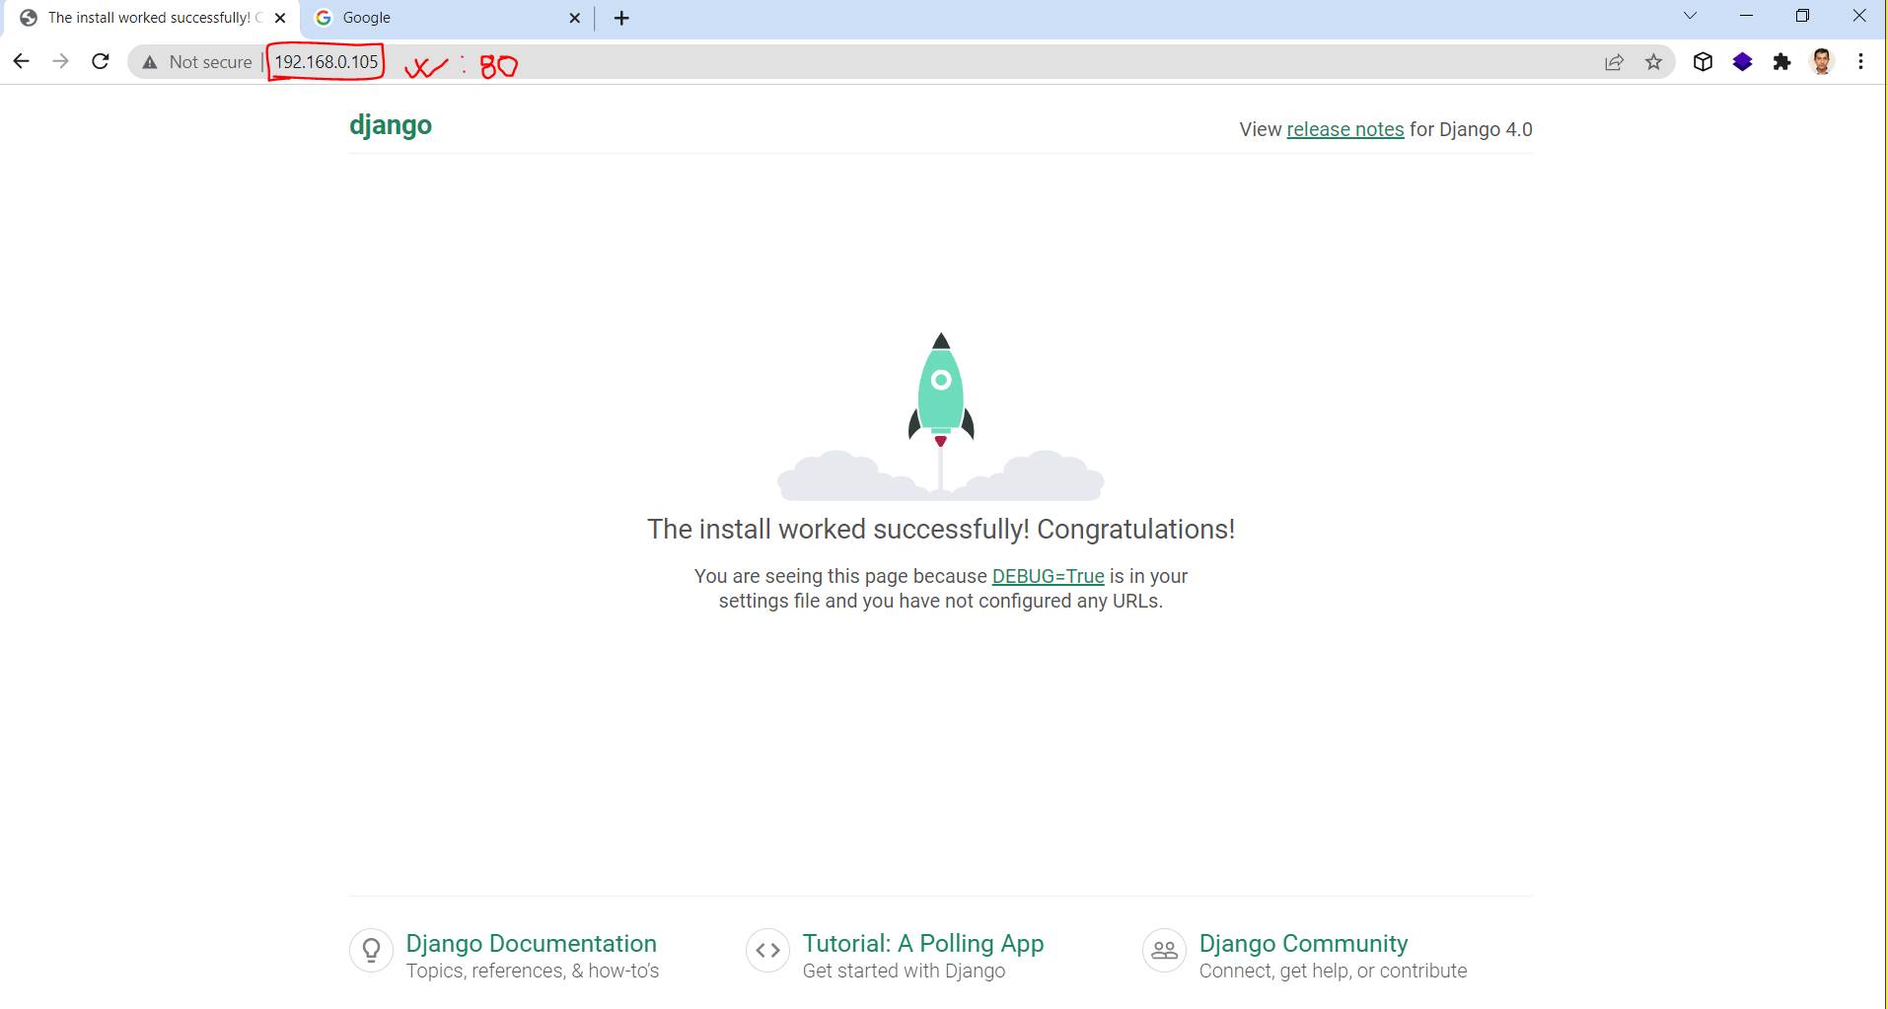

**Manage.py terminal**

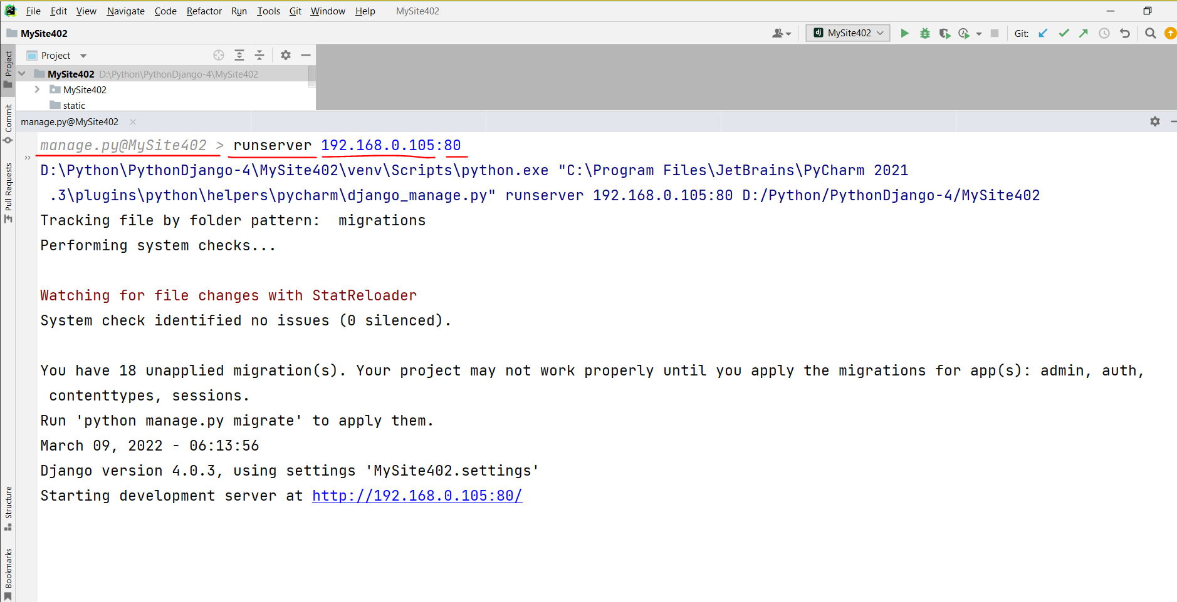

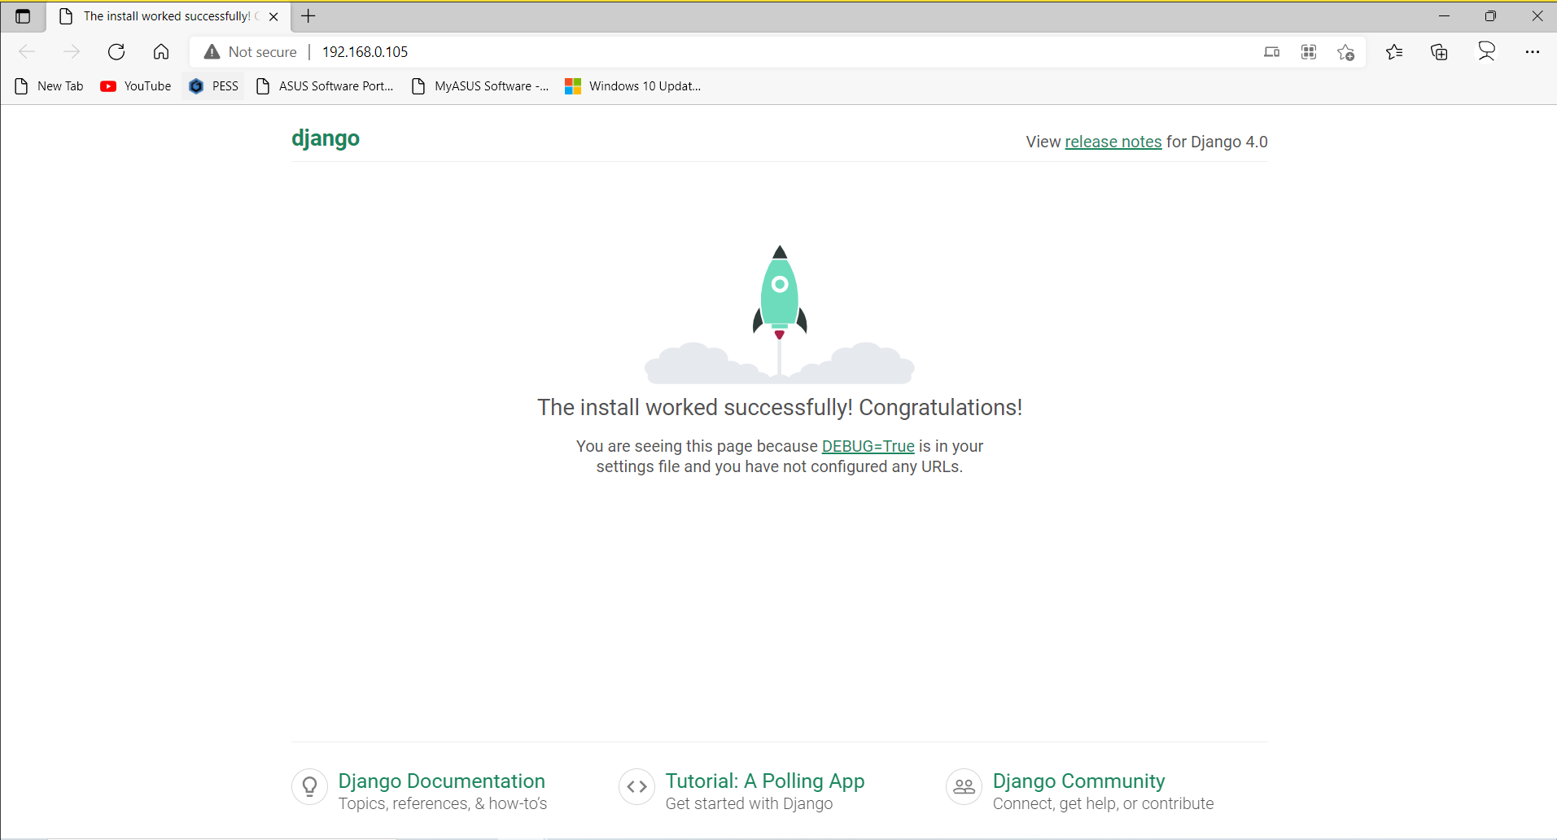

**Task-1**

* Display “Hello world of Django!” in browser.

**Solution-1 (RootDir)**

* Create **views.py** file
  + Create view **function** to return “Hello world of Django!”

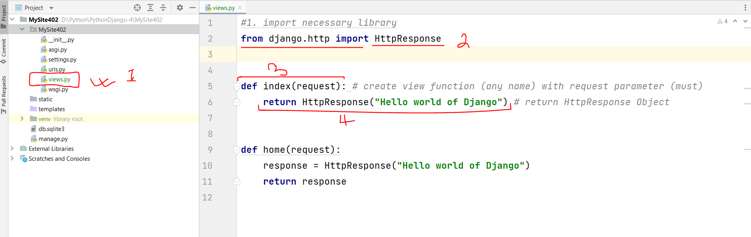

* Create **new url pattern** (update root’s **urls.py** file)

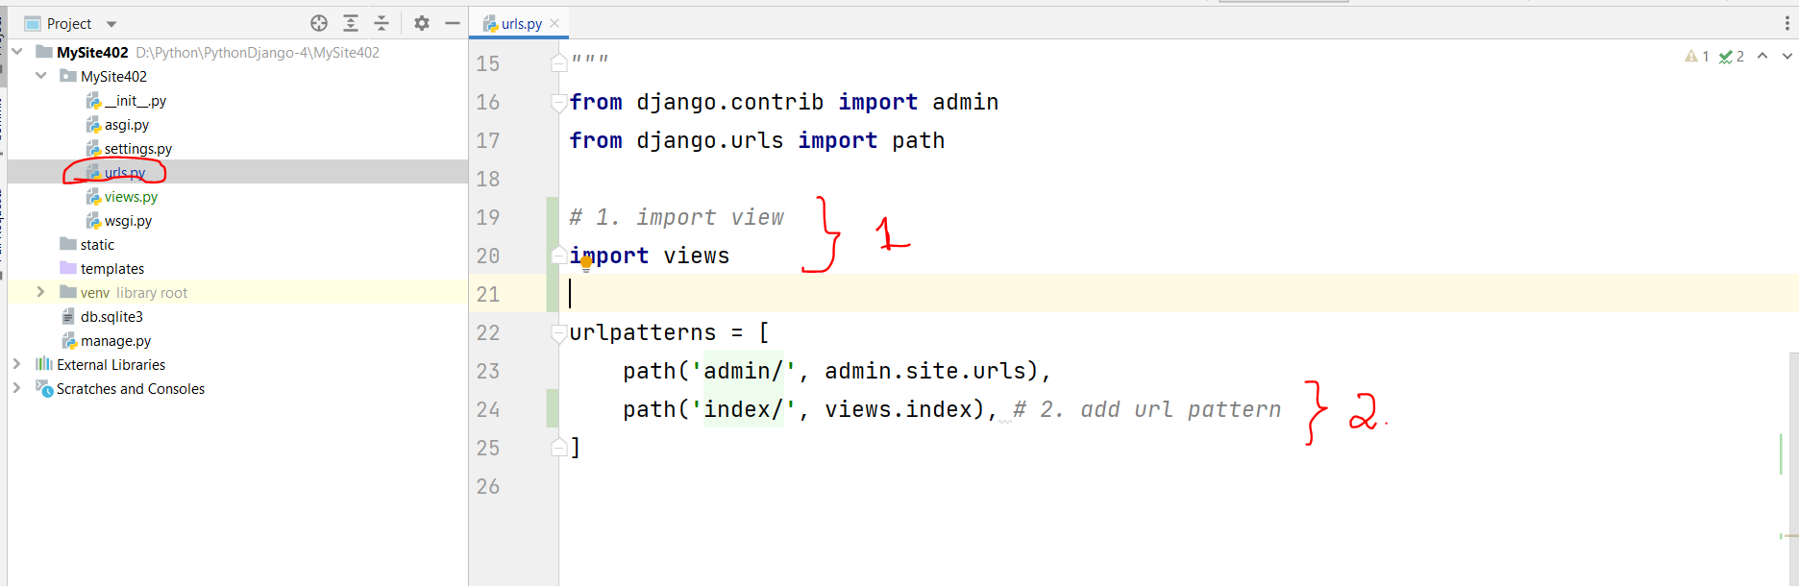

* Run server and browse

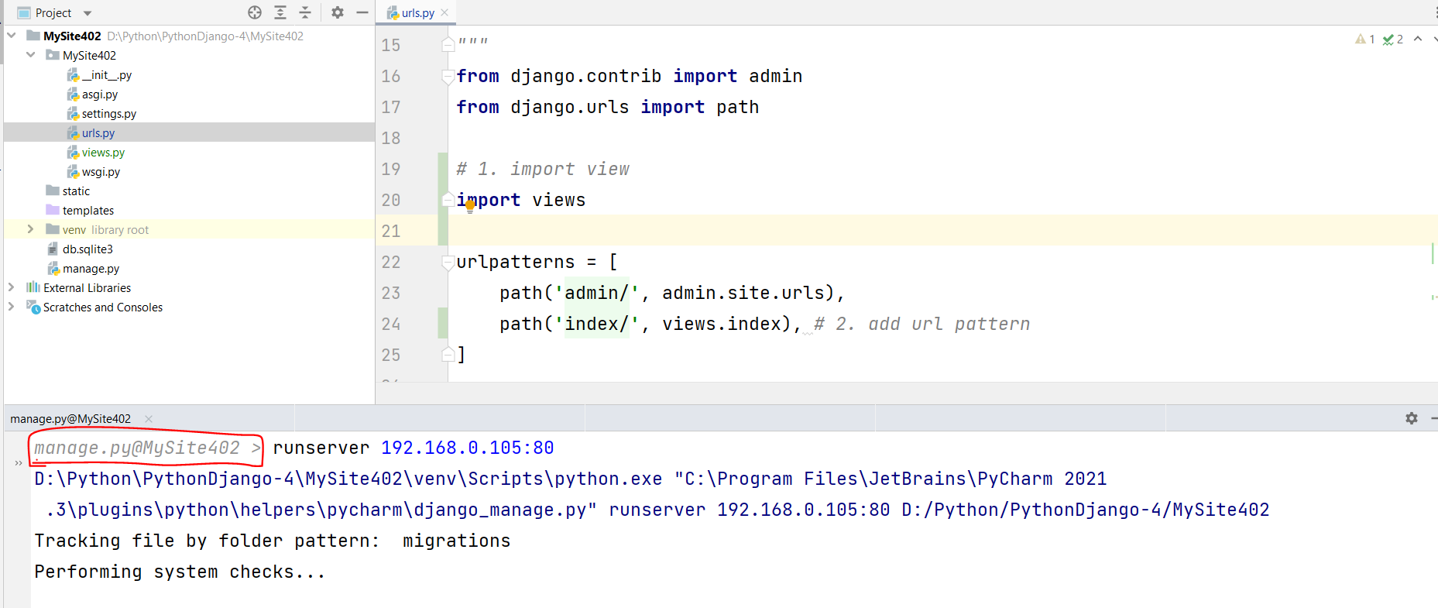

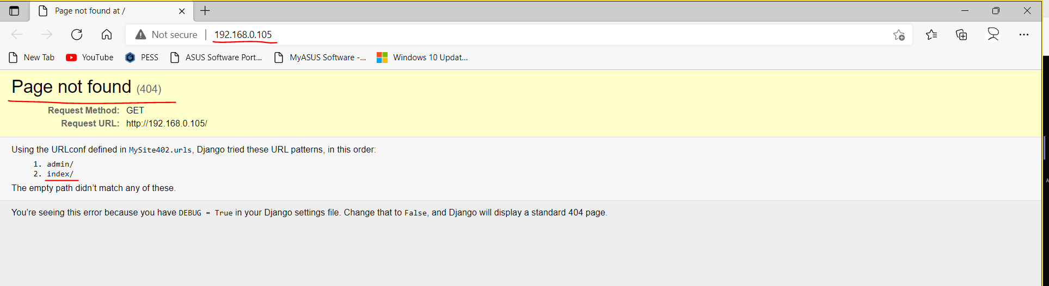

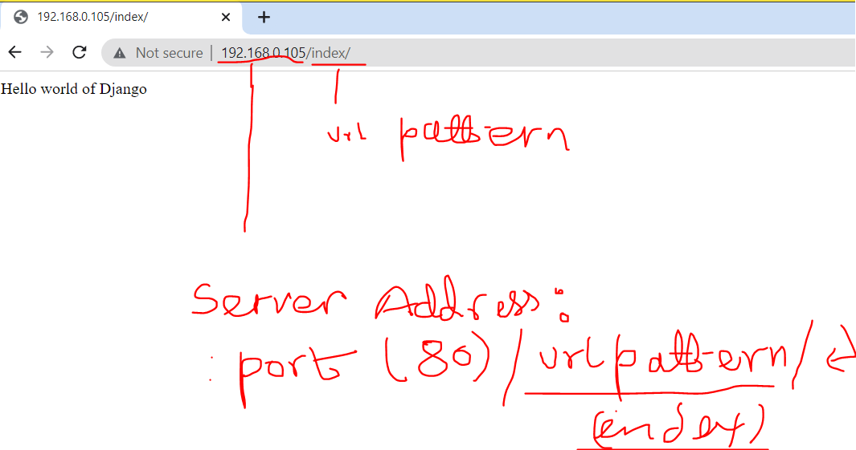

**Task-2:** Create the following views functions and urls pattern to call respective view functions.

* defualt (Home page)
* successgallery
* testimonials
* onlineadmission
* paymentoption
* offers
* career
* contactus
* blog

**Solution-2 (App)**

* Creating new app
  + Terminal -> python manage.py startapp **app1_1**

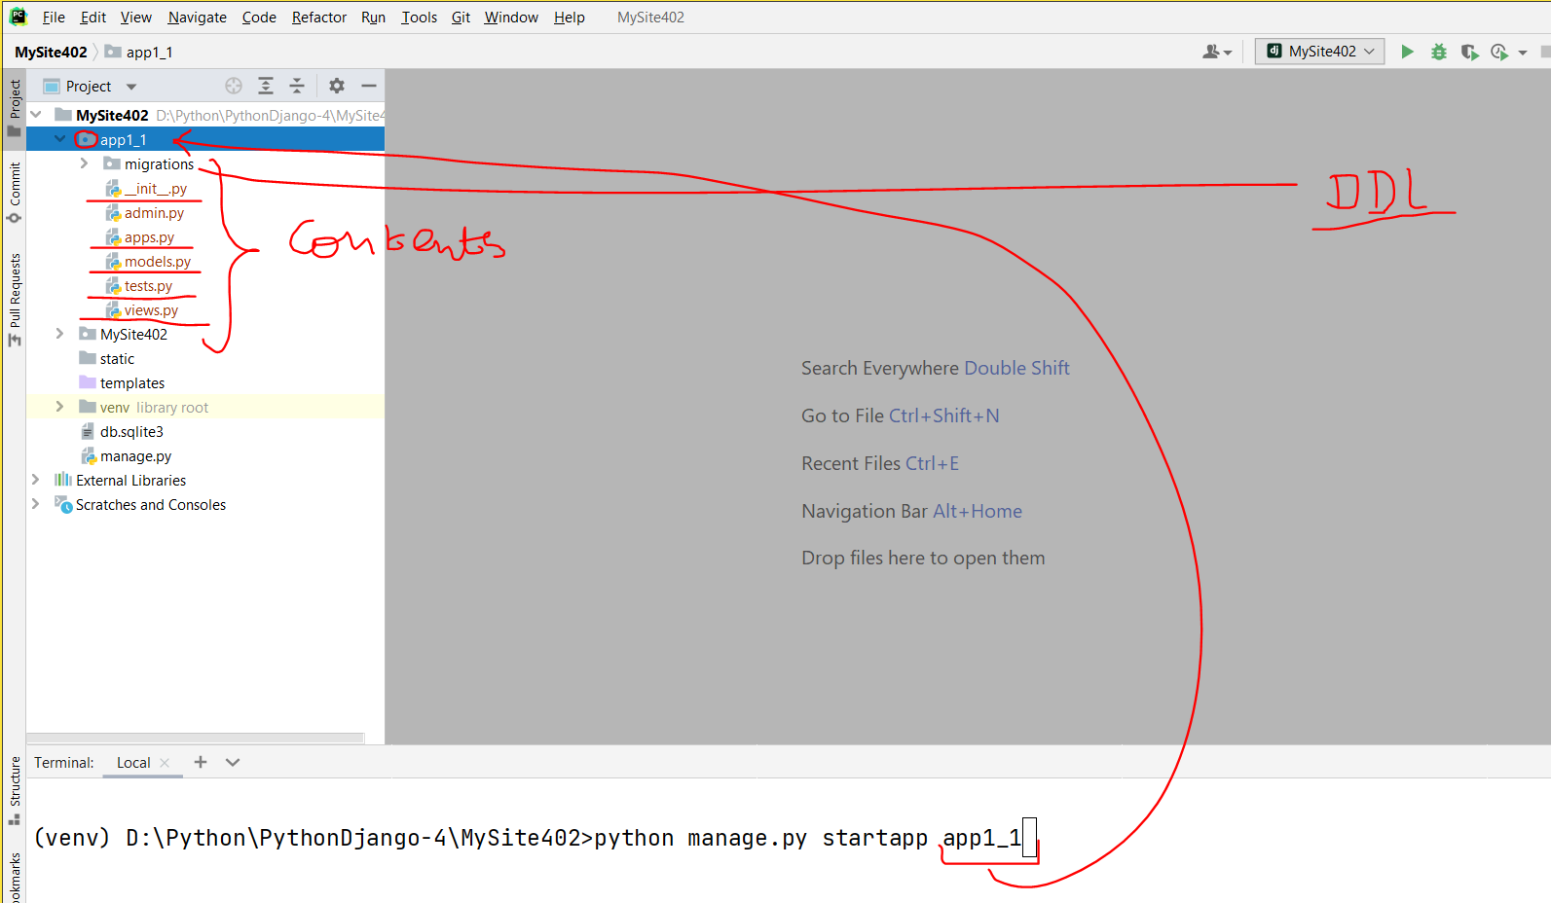

* Register app in rootdir/settings.py -> INSTALLED_APPS -> add app_name in list ‘**app1_1**’

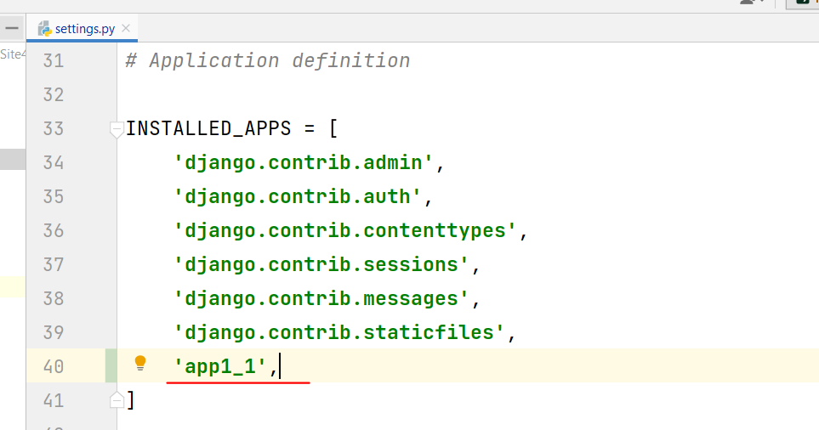

* Create views functions in app (app1_1\**views.py**)

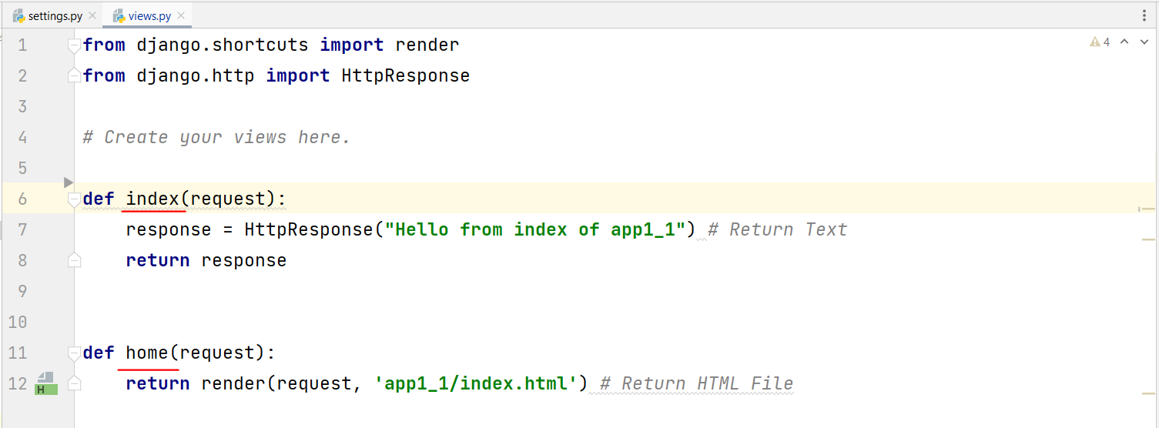

* Create new urls.py file in (app1_1\**urls.py**)

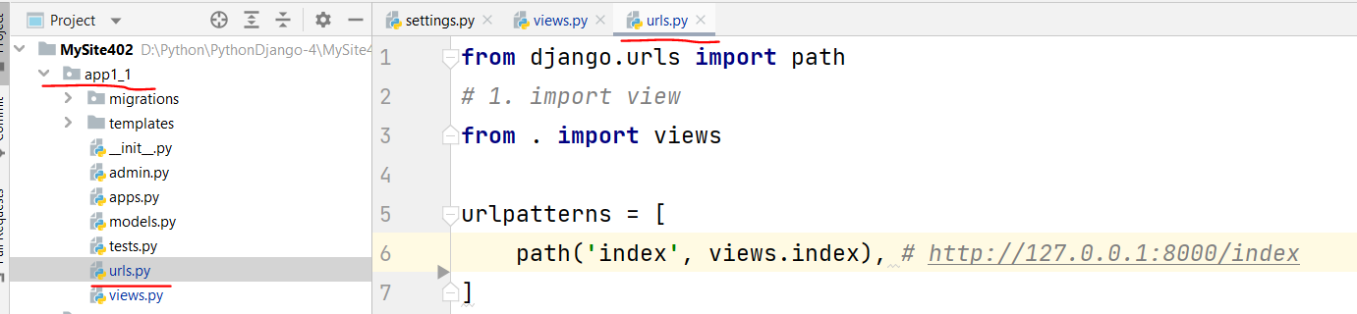

* Update in root urls.py (MySite402\**urls.py**)

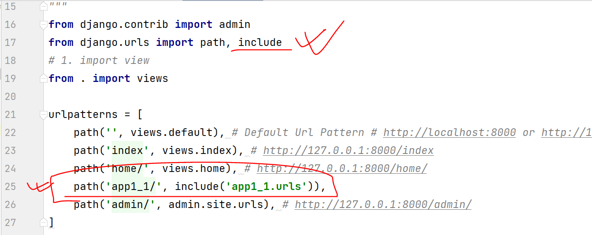

* Browse Site

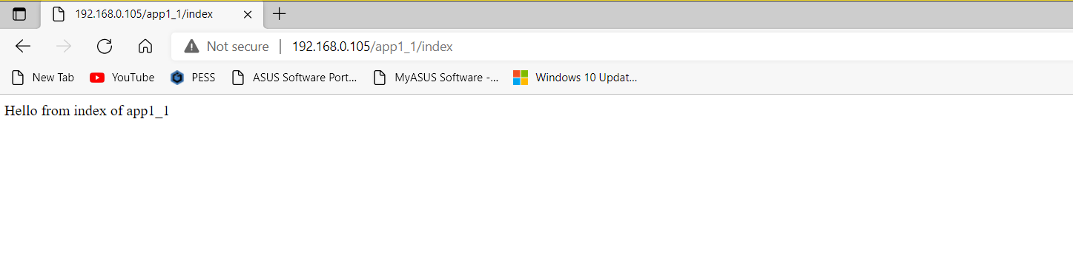

**Task-2:** Create multiple apps and integrate in site.

* defualt (Home page)
* successgallery
* testimonials
* onlineadmission
* paymentoption
* offers
* career
* contactus
* blog

**9. Loading Static Contents (css, image, javascript).**

* Create new app (**app1_2**)

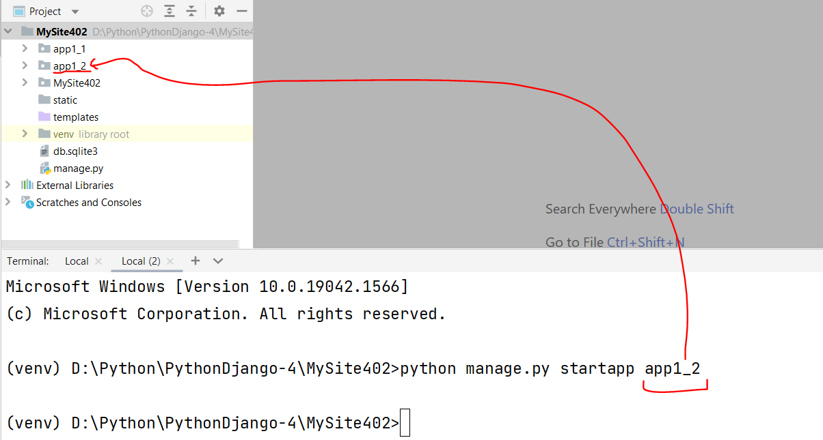

* Register newly created app (root\settings.py\**INSTALLED_APPS**)

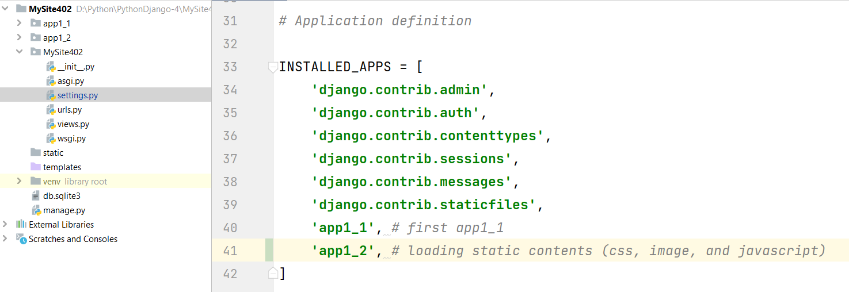

* Upate in root\settings.py by adding **STATIC_ROOT**
  + Create **static** folder in base dir

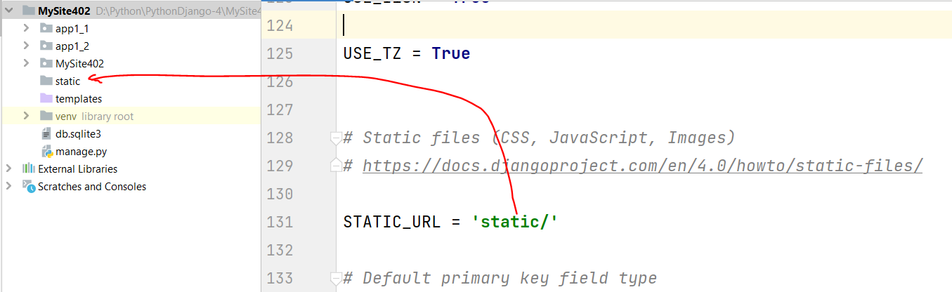

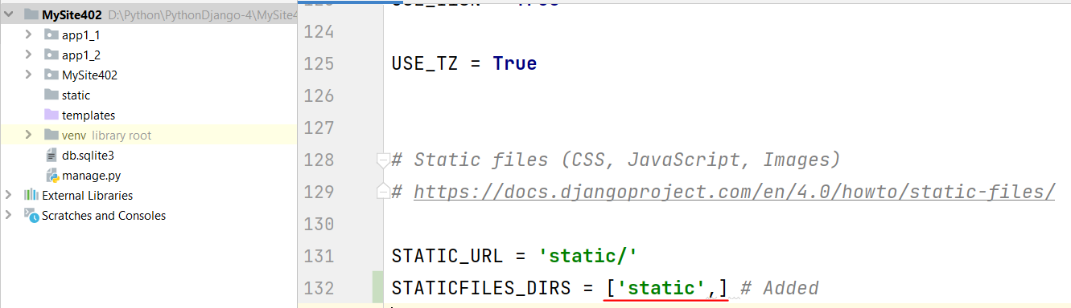

* Create static contents (**css, image, and JavaScript**)
  + BaseDir\static\app1_2\**css** – folder
  + BaseDir\static\app1_2\**images** – folder
  + BaseDir\static\app1_2\**js** – folder
* Create template (**html file**)
  + app1_2\templates\app1_2\**index.html**
* Import/Link **static contents** in template (index.html)

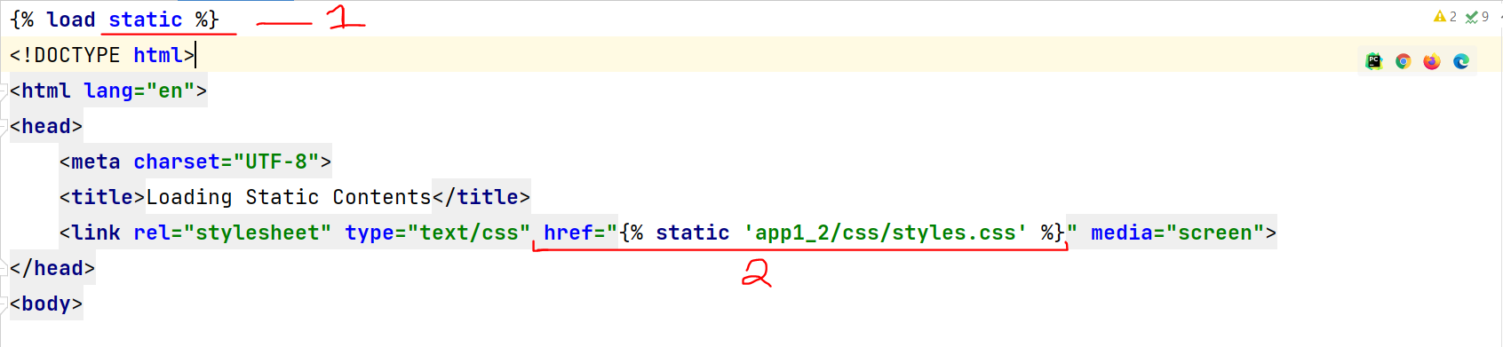

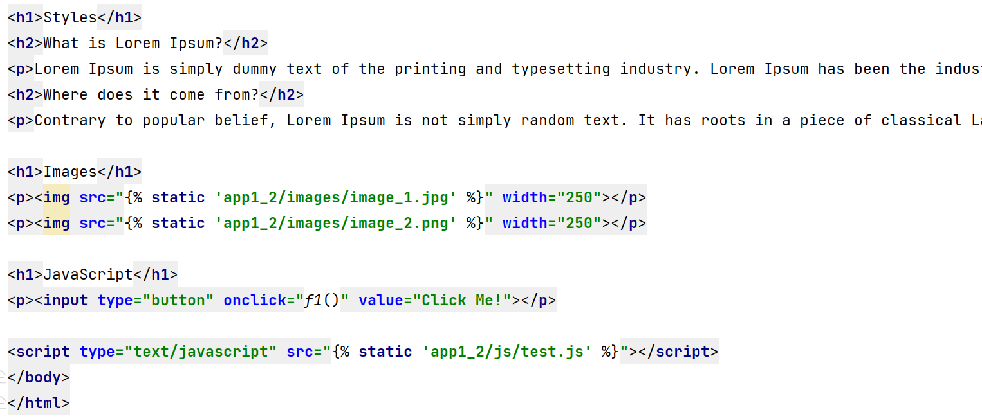

* Create **view** functions in app1_2

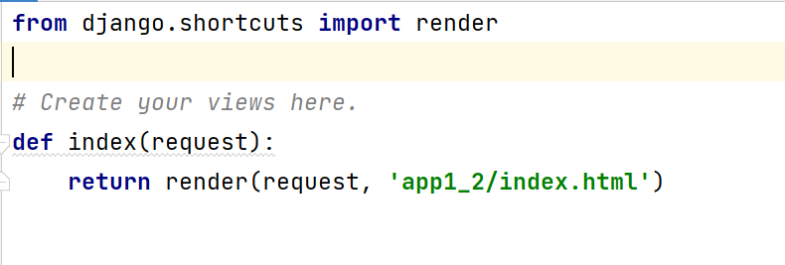

* Create **urls.py** in app1_2

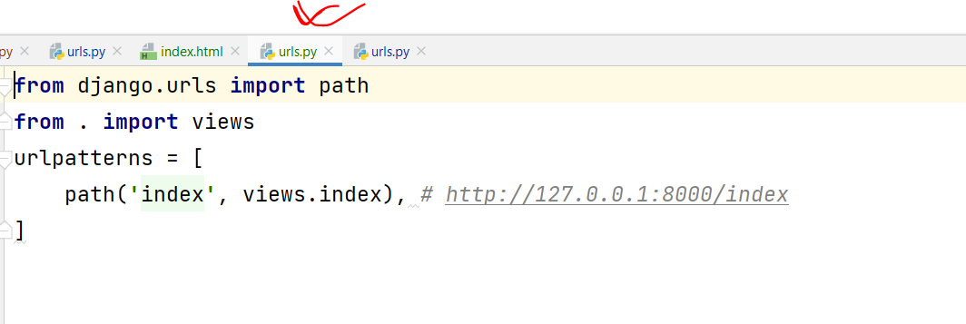

* Update **root\urls.py**

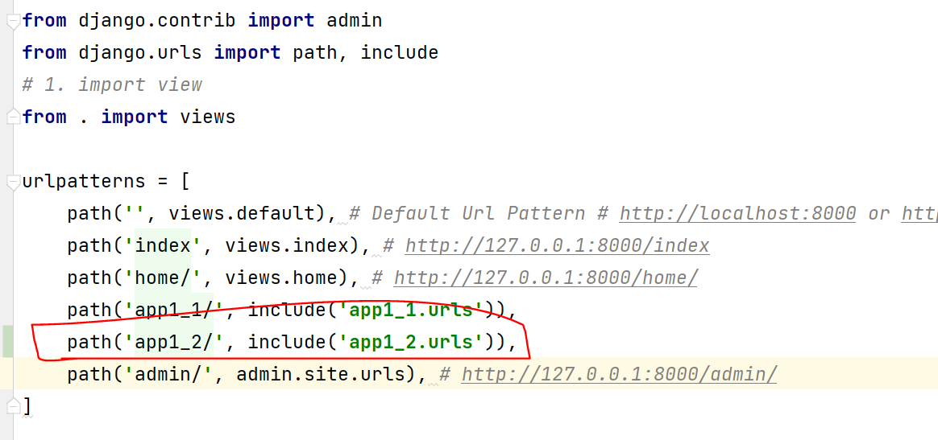

* **Browse site**

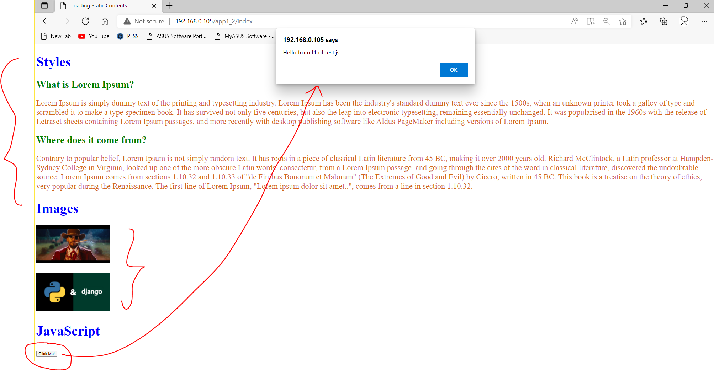

**Note:**

* **HTML, CSS, JavaScript**
* **Bootstrap**
* **Node**, and **Angular**/View/React JS

**Task-3 (Project):** Create multiple apps and integrate in site with static resources (**css, images, javascript files**).

* home (default)
* successgallery
* testimonials
* onlineadmission
* paymentoption
* offers
* career
* contactus
* blog

**home (default)**

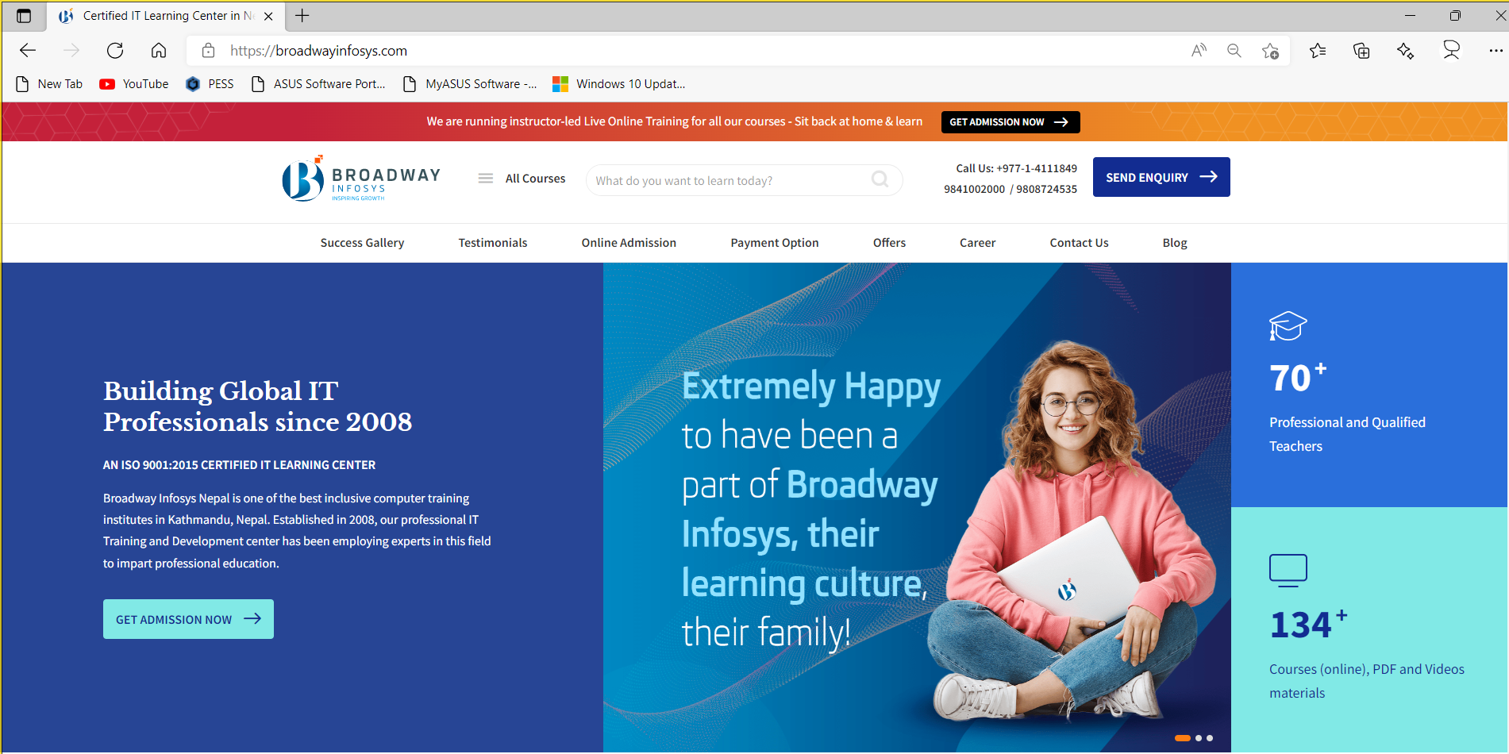

**successgallery**

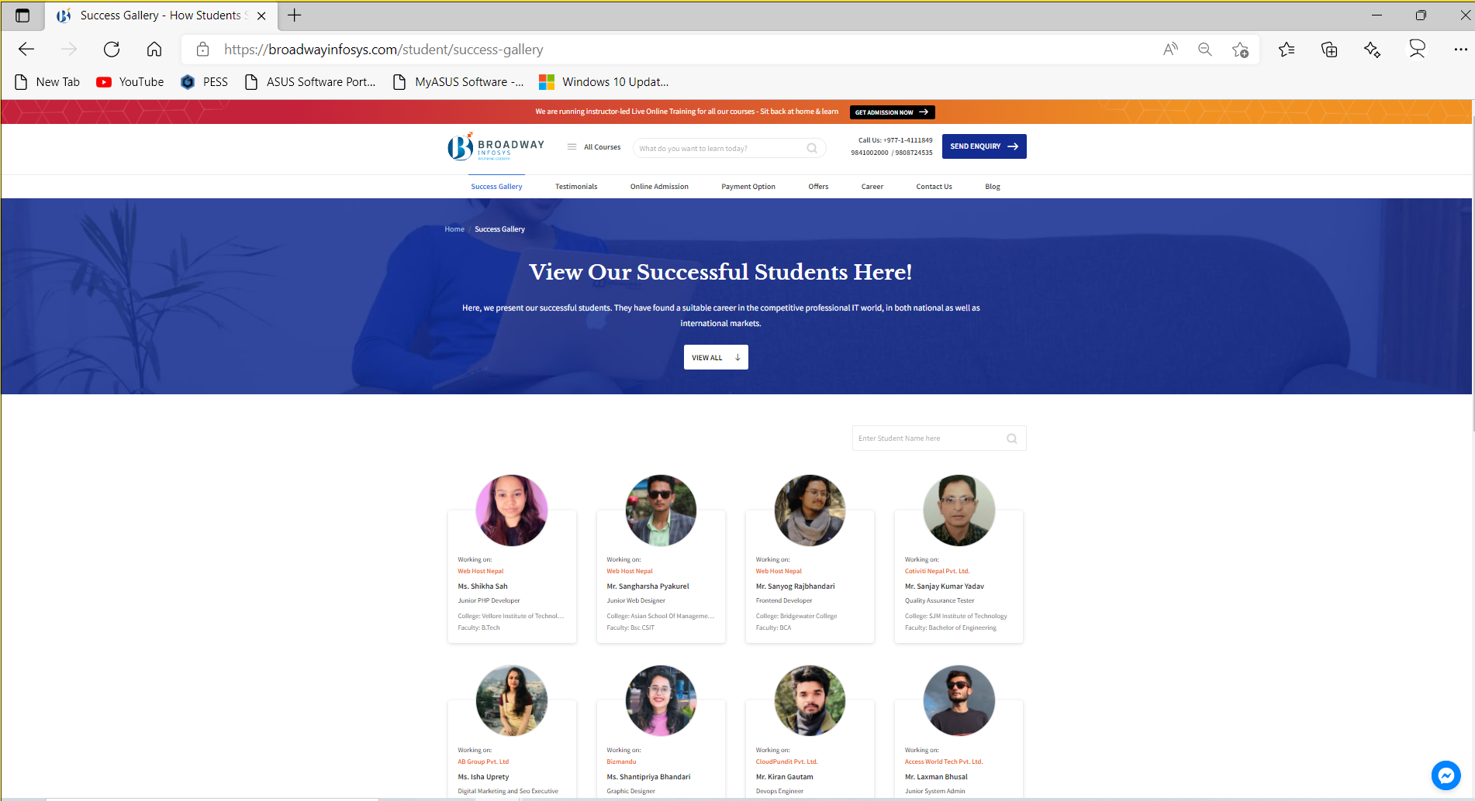

**testimonials**

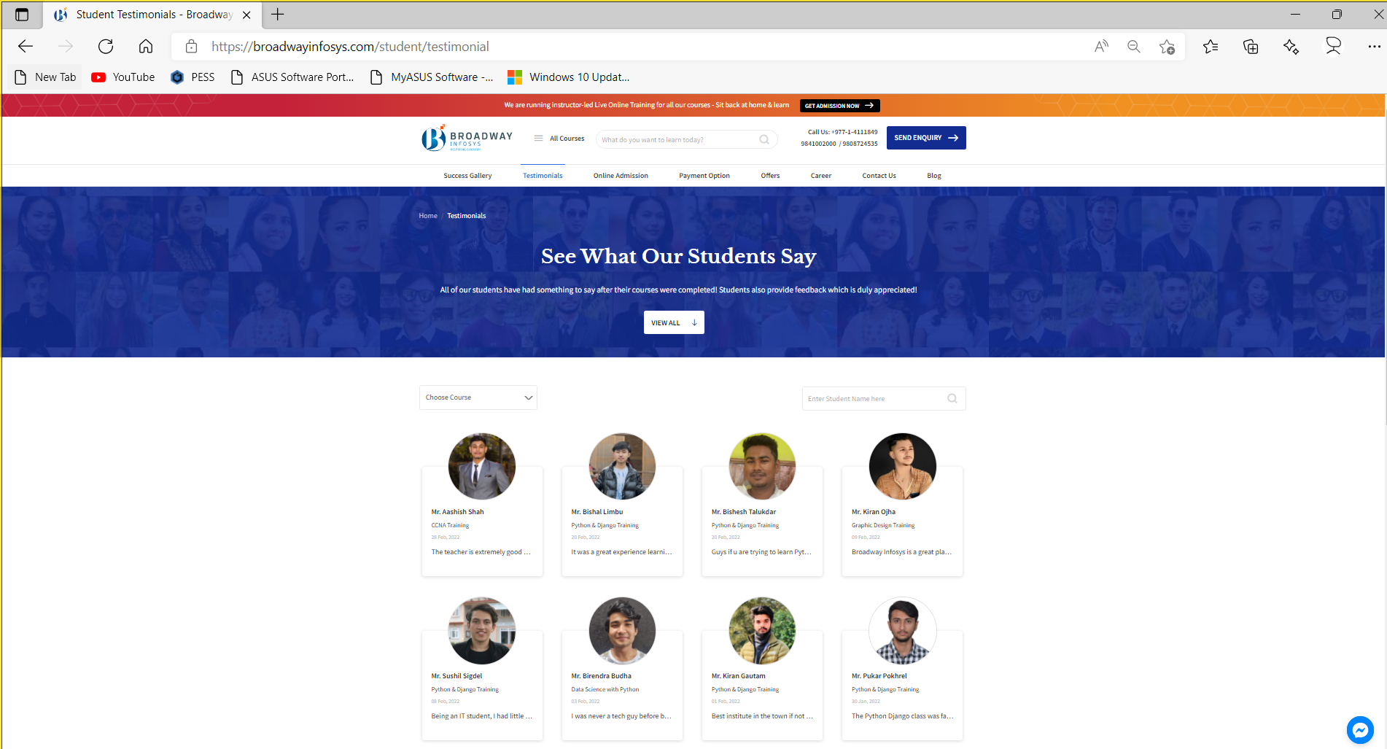

**onlineadmission**

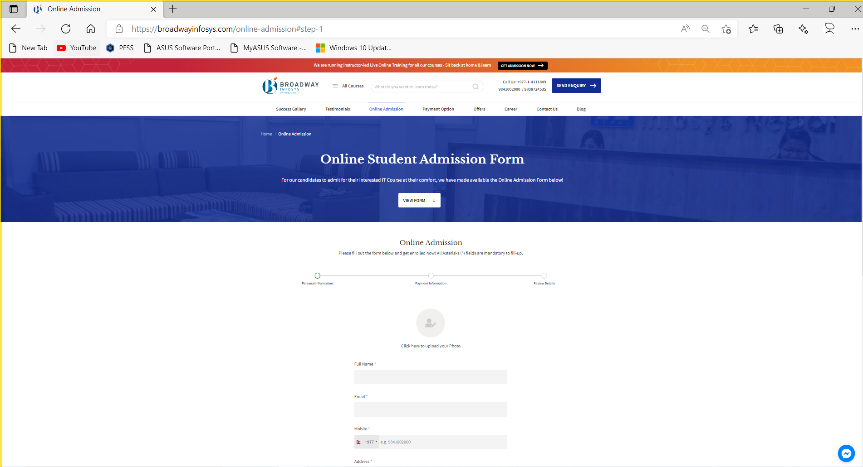

**paymentoption**

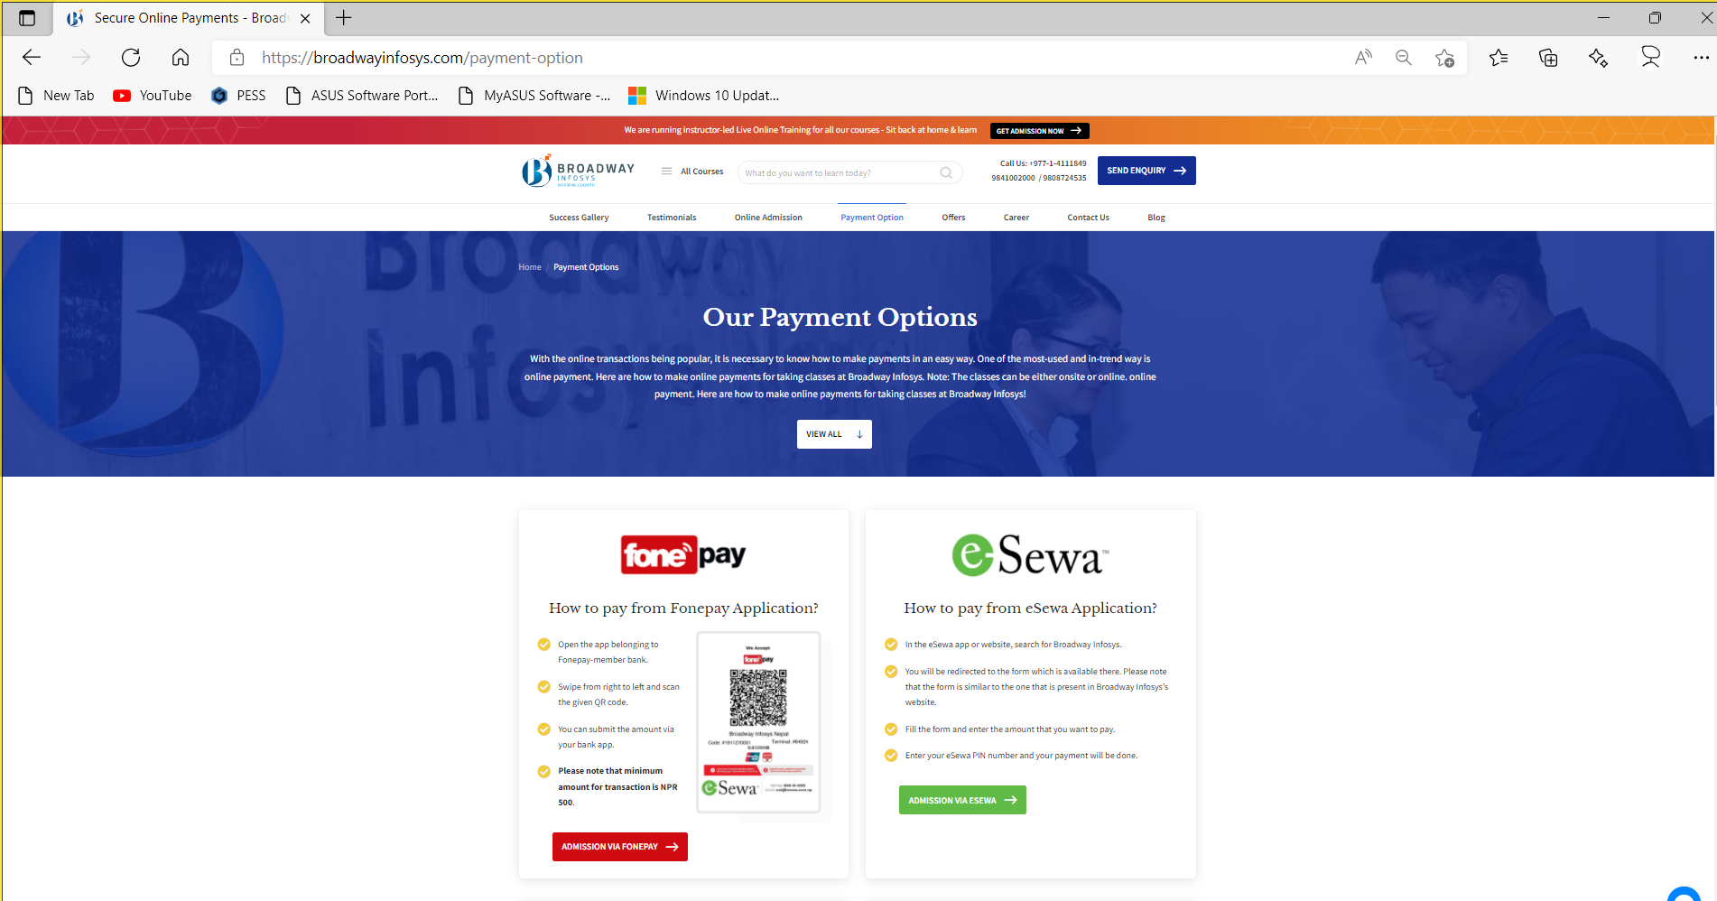

**offers**

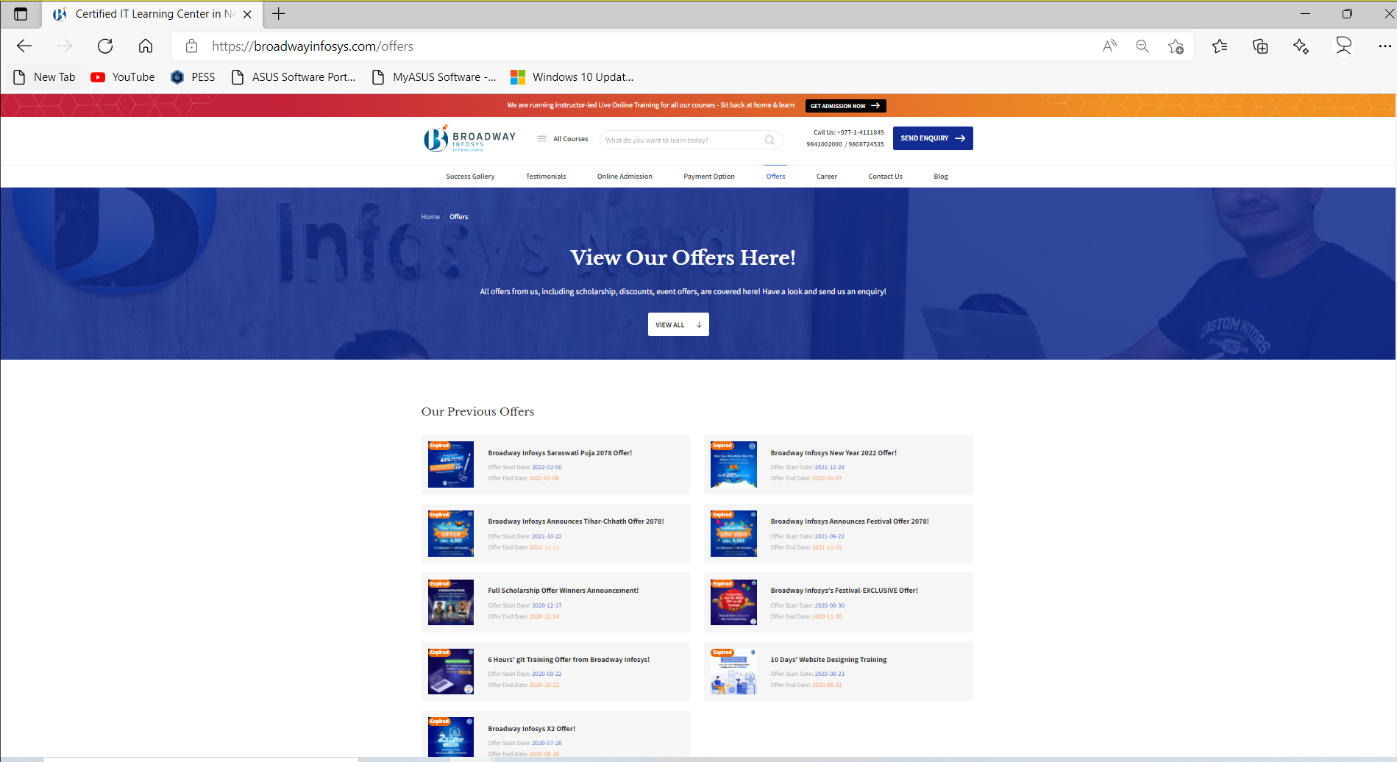

**career**

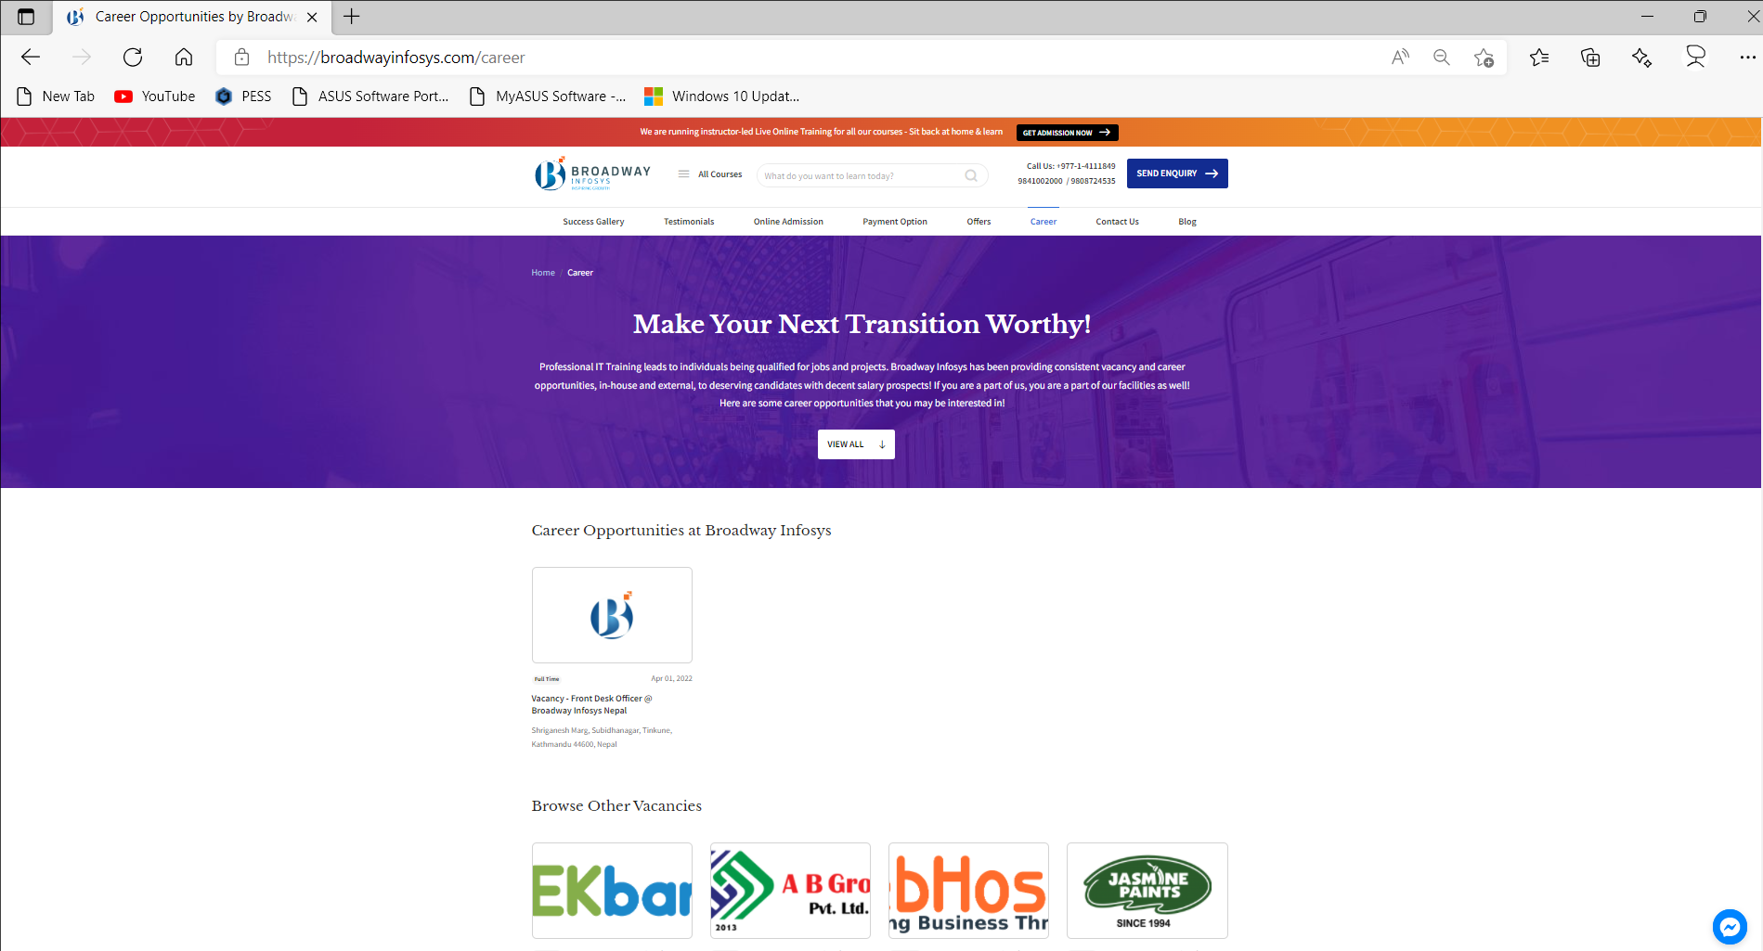

**contactus**

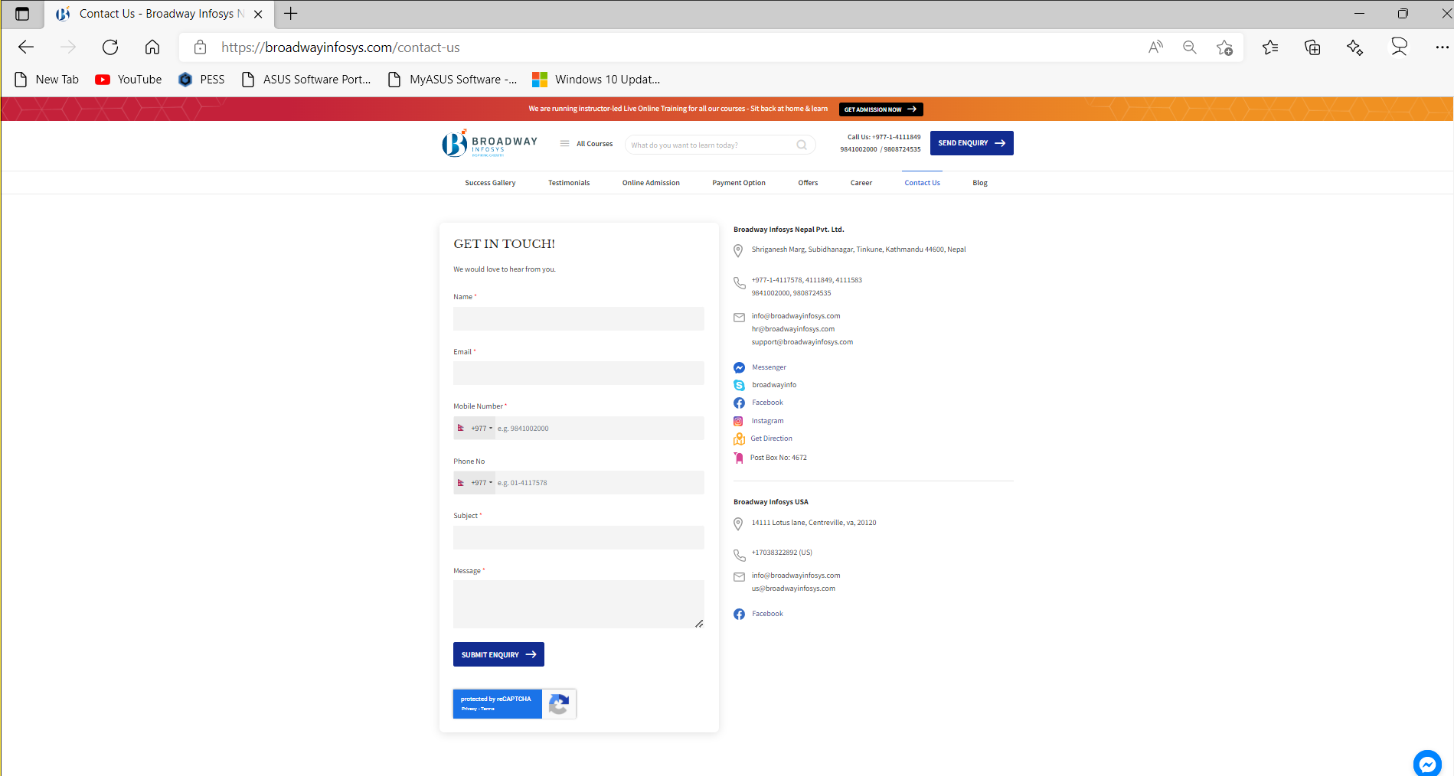

**blog**

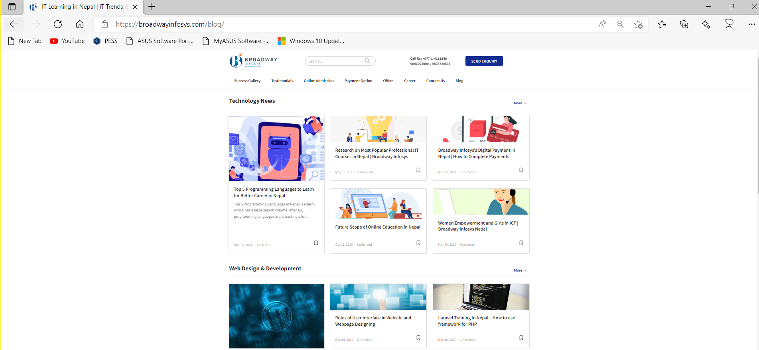

**10. Bootstrap integration**

* Download/Documentation resources
  + https://getbootstrap.com/
* Integrate Bootstrap-1 – **Online** (CDN)
  + Create new app (**app1_3**)
  + Register newly create app in **setting.py**
  + Create template file (app1_3\templates\app1_3\**index.html**)
  + From the documenation section of bootstrap library copy the template of starter and pate on **index.html**
    - https://getbootstrap.com/docs/5.1/getting-started/introduction/
  + Create view function in **views.py**
  + Create urls.py in **app1_3**
  + Update root\**urls.py** file (add app1_3\**urls.py**)
  + Browse the site
* Integrate Bootstrap-2 – **Offline**
  + Donwload bootstrap library (Compiled CSS and JS)
    - https://getbootstrap.com/docs/5.1/getting-started/download/
  + Create new app (**app1_4**)
  + Create static folder (app1_4\static\**app1_4**)
  + Place css and js folder in app1_4\static\**app1_4**
  + Create html template (app1_4\templates\app1_4\**index.html**)
  + Load static contents in **index.html** (**css, and js**)
  + Create app1_4\**urls.py**
  + Create index function in app1_4\**views.py**
  + Update root\urls.py file (add app1_4\**urls.py**)
  + Browse the site

**Task-4:**

* Create new app (app1_4) test **layout**, **content**, **forms**, **components** of bootstrap (integrate and cutomize as per requirements)

**11. Bootstrap one page site integration**

* https://bootstrapmade.com/bootstrap-one-page-templates/

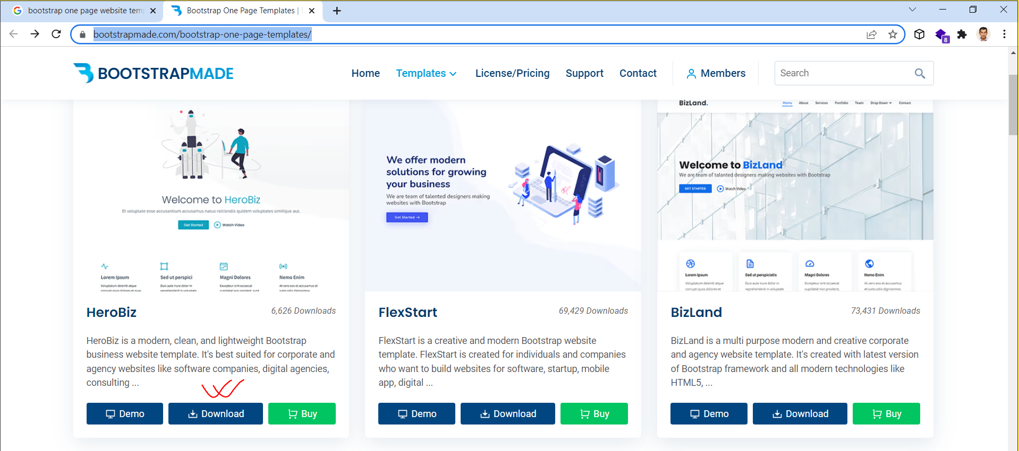

* Extract and run **index.html**

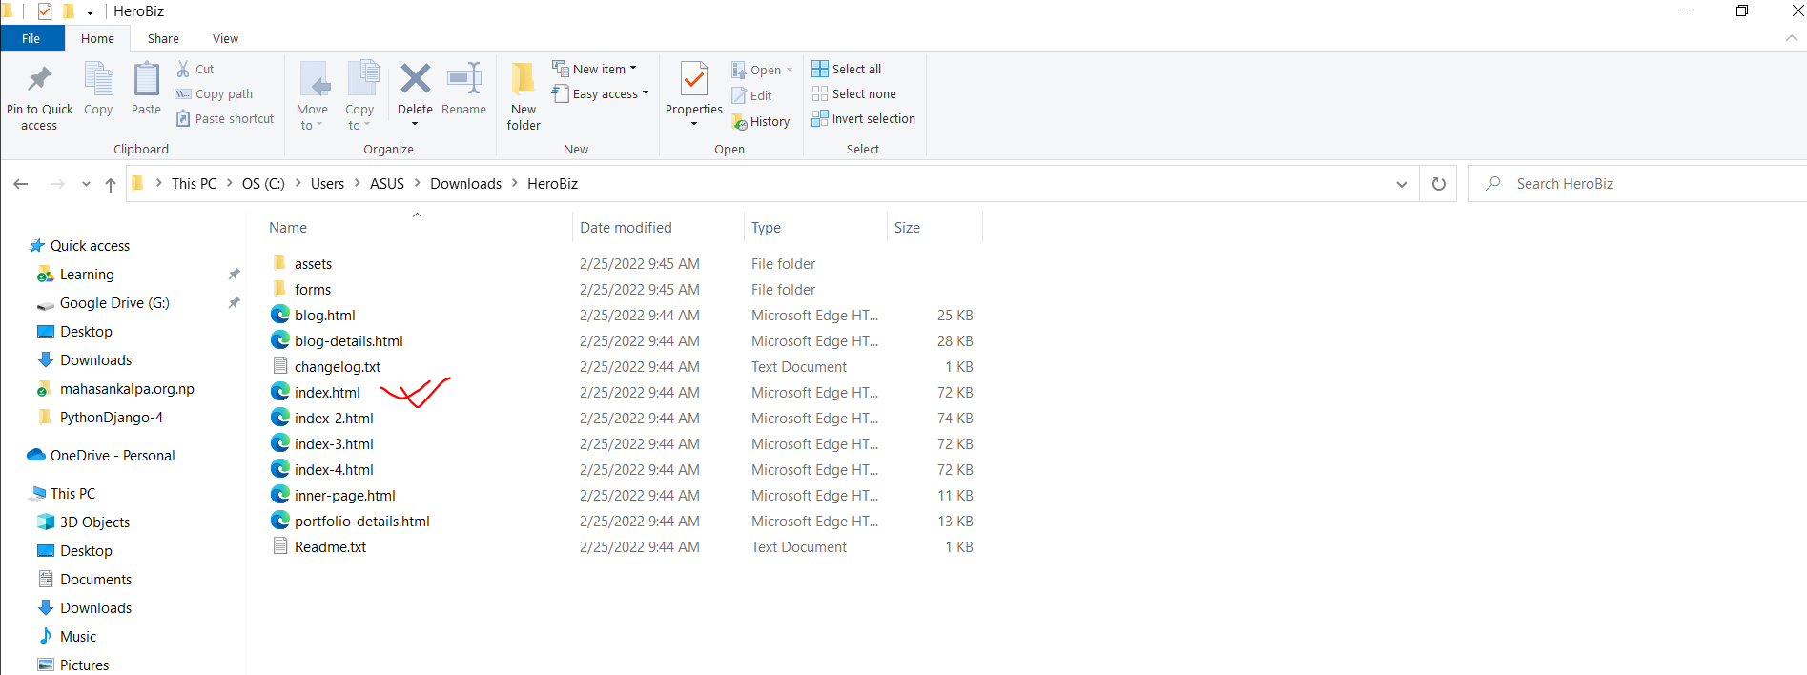

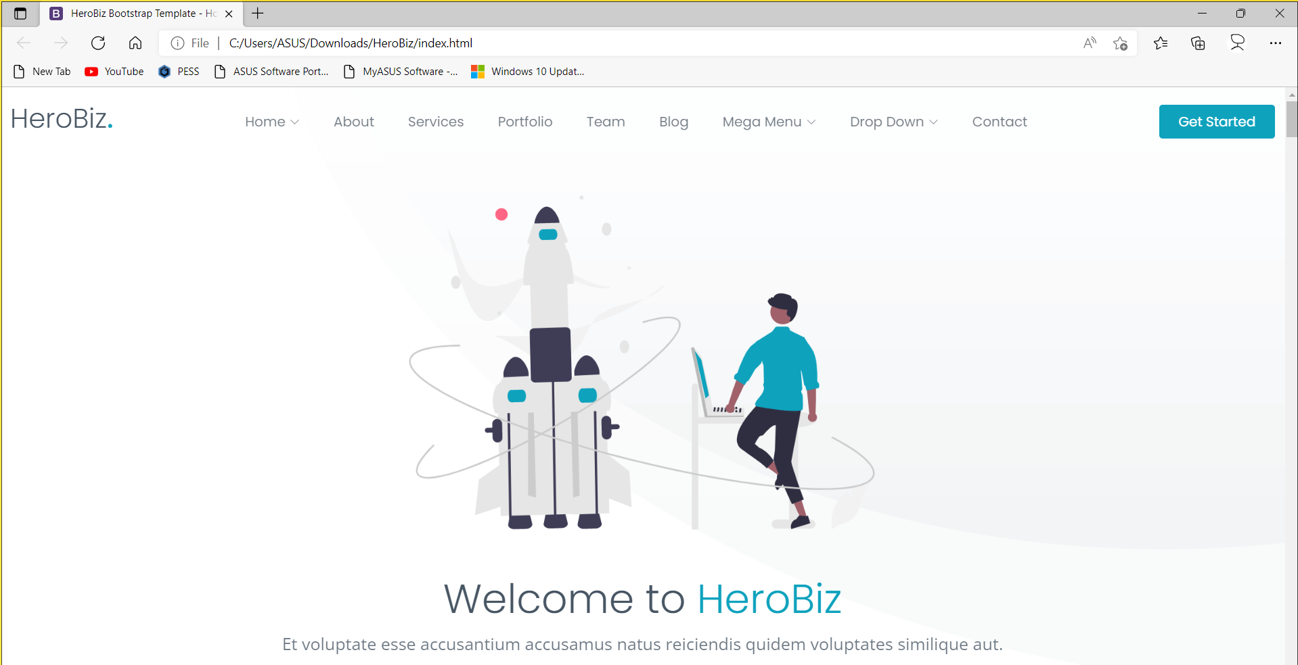

* Create new app **app1_6**
* Register app in **settings.py**
* Create **templates\app1_6** folder in app1_6 app
* Place **index.html** file in app1_6 of template folder
* Create view function to render index.html (views.py)
* Create **urlpattern** in **urls.py (‘index’)**
* Update in root\**urls.py**
* Browse the site
* Create **static** folder in app1_6
* Paste **assets** folder in static folder
* Update **index.html** file with static contents
* Browse the site

**12. Sending values (data) from client to server.**

**MVT (Model, View, Template)**

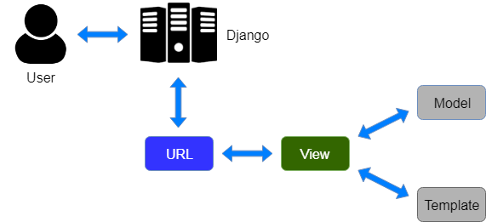

**12.a. Sending value from url**

* Create new app (**app1_7**)
* Register newly created app in **setting.py**
* Create **urlpattern** and **view function (app1_7)**
* Update **root\urls.py (add app1_7\urls.py)**
* Browse the app

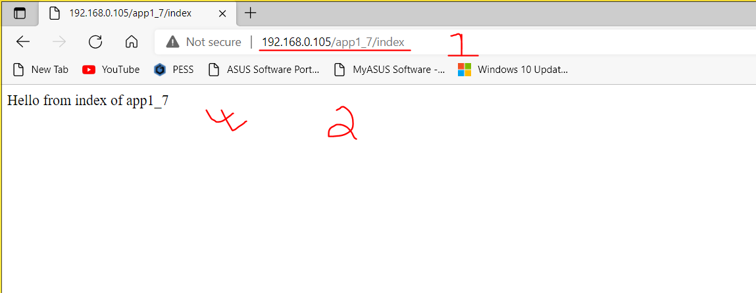

* **Sending value from url to views**

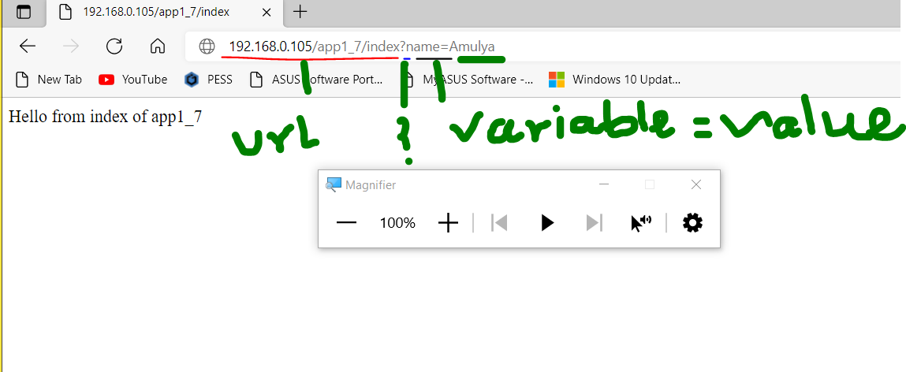

* **Receive value in views**

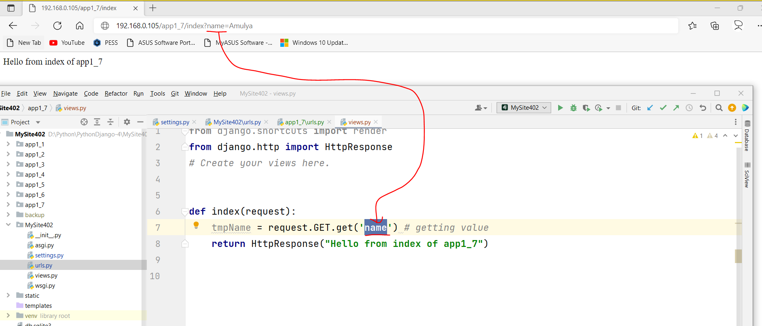

* **Redirect value to Terminal and Browser**

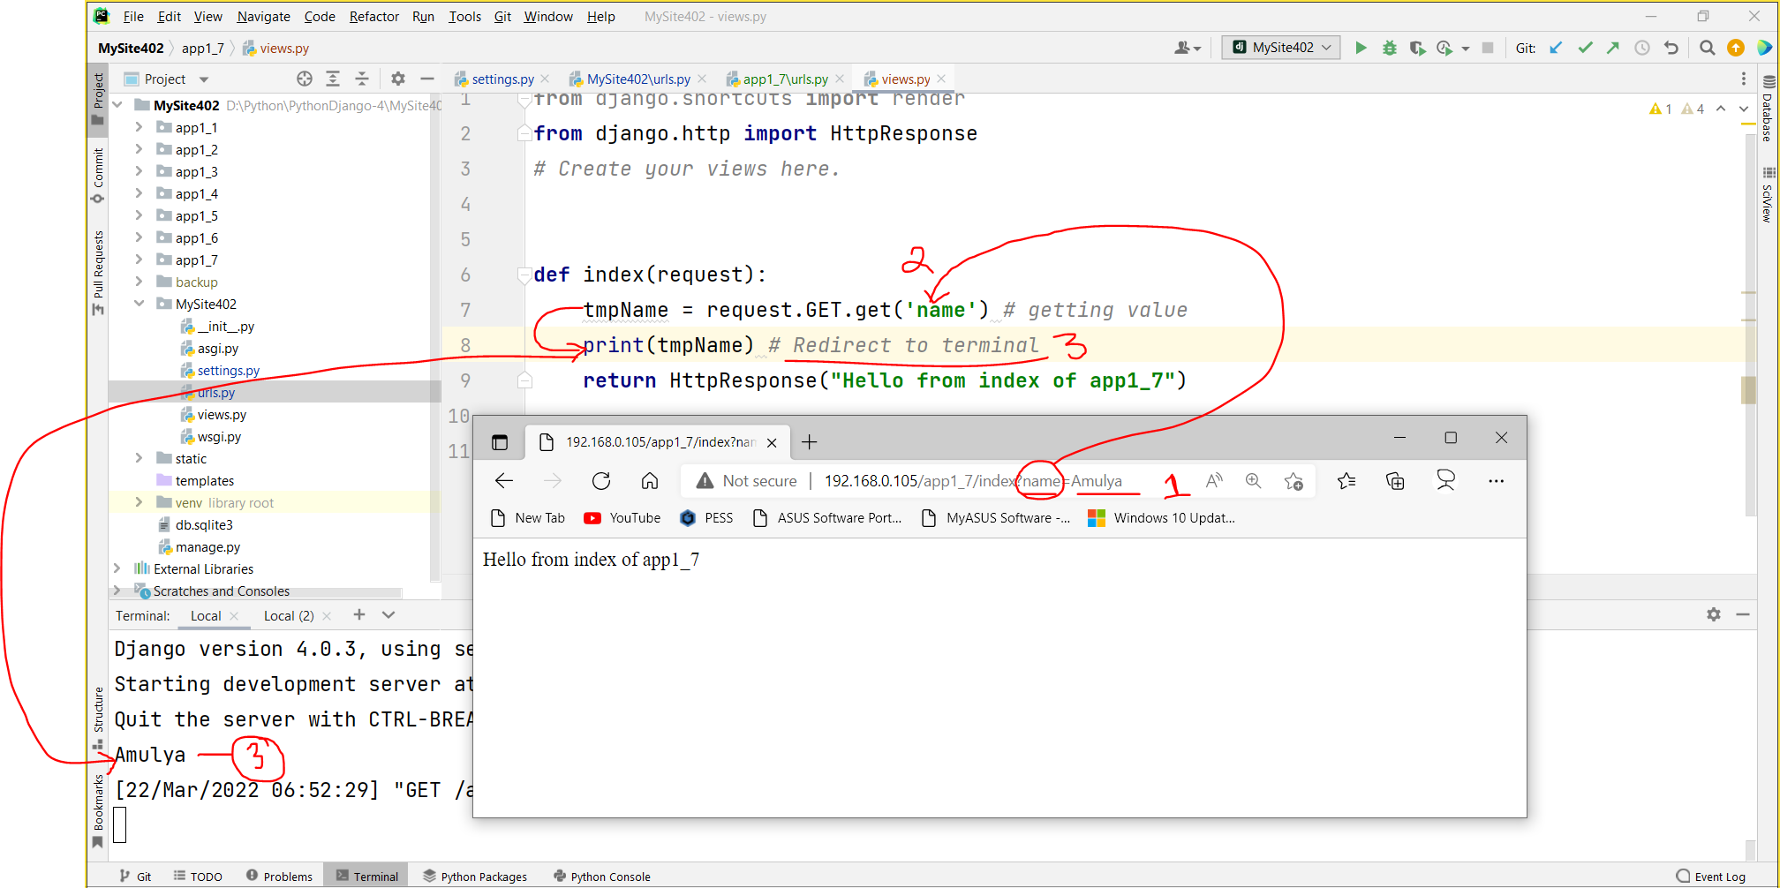

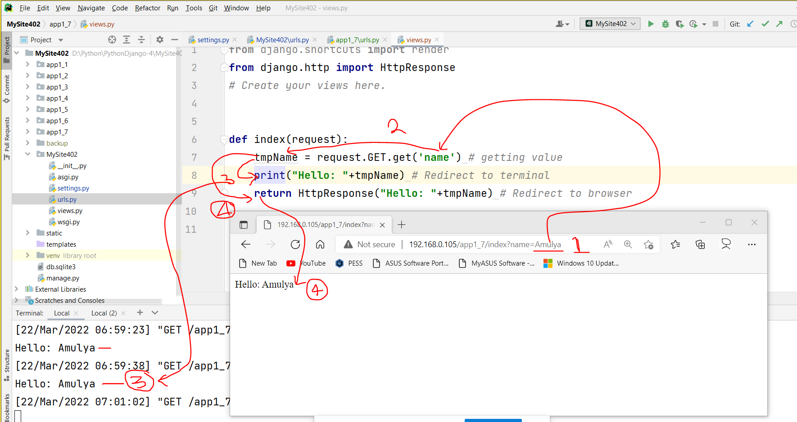

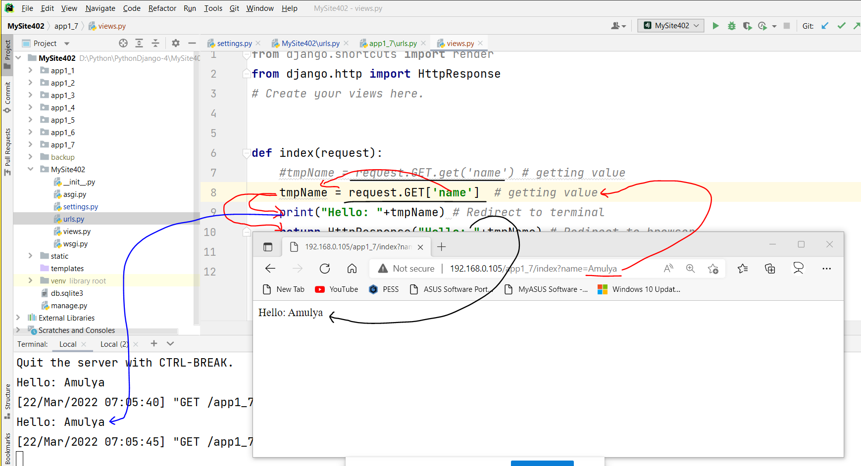

* **Redirect to template (html file)**
  + Create template file (html file [app1_7\templates\app1_7\index.html])
  + Render template (html file)
  + Sending value to tmplate

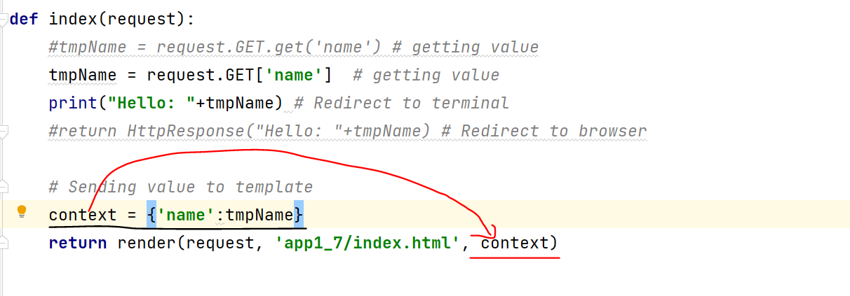

* + Display **value** on **template (html file)**

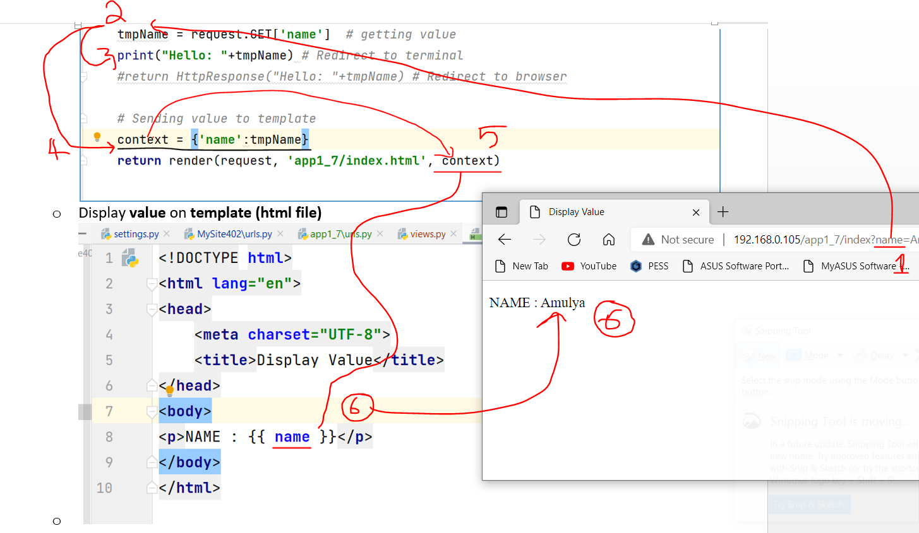

* **Task-5**
  + Send two numbers and one operator from URL and redirect the result in template as per operator (+, -, *, **, /, //, %, pow).

**12.b Sending value from web form.**

* + Create new app (**app1_8**) and register
  + Create app1_8\**urls.py**
  + Update root\**urls.py (add url pattern for app1_8)**
  + Create html templates
    - app1_8\templates\app1_8\**form1.html (Web form)**
    - app1_8\templates\app1_8\**index.html (Result publish)**
  + Create web form (**form1.html)**

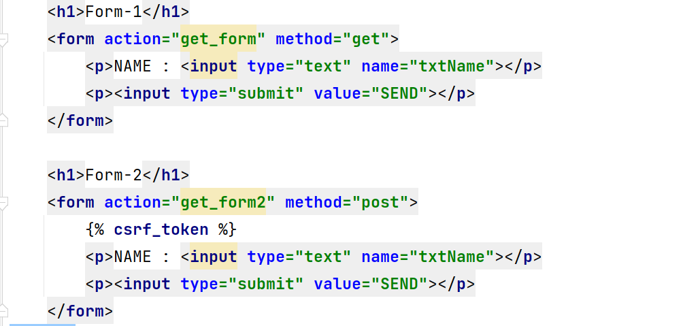

* + Update on **views.py**

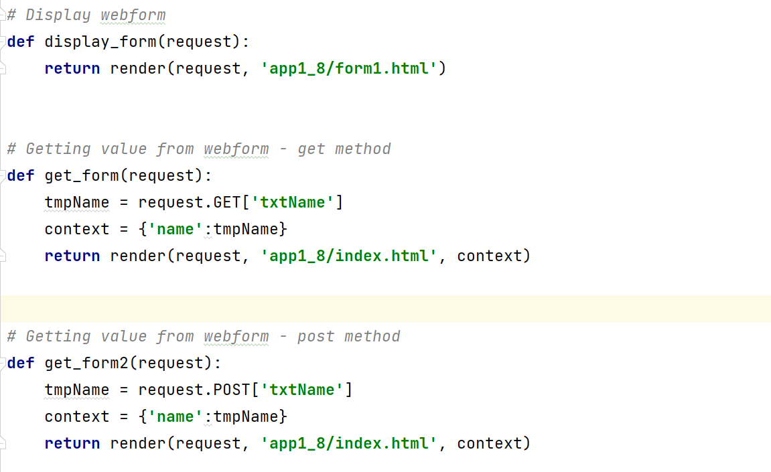

* + Update on index.html

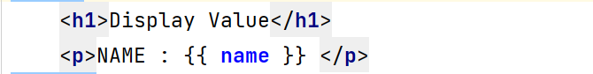

* + Update on **urls.py**

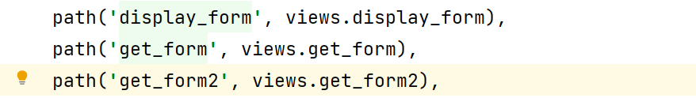

* + Browse the **site-1**

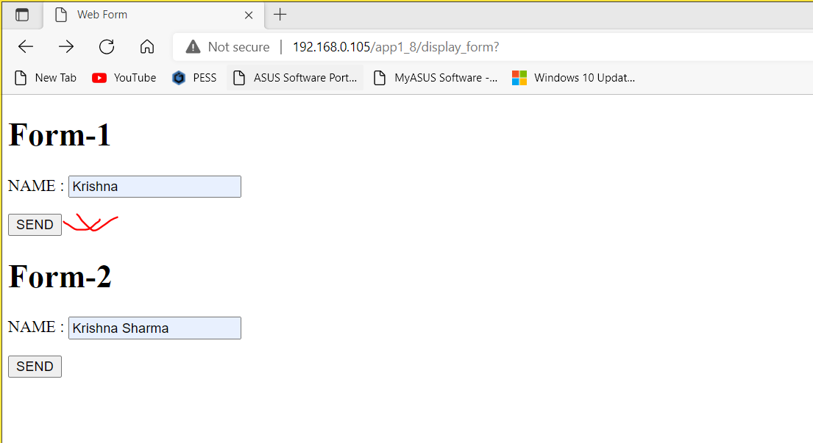

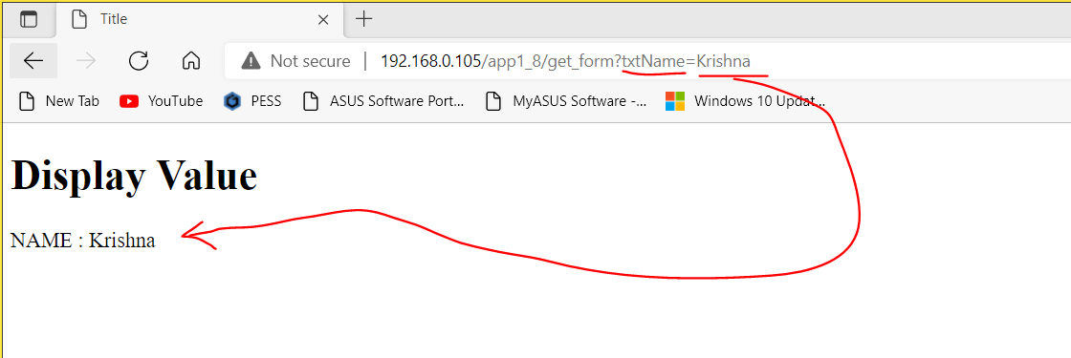

* + Browse the **site-2**

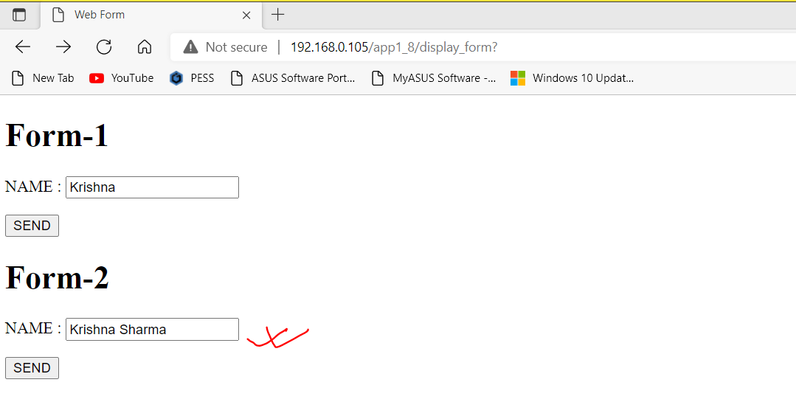

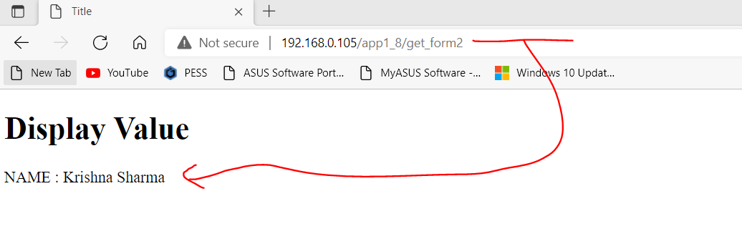

**Task-6:**

* Receive values from contact us form and save in **database table** (sqlite)/**text file**. (app1_6).

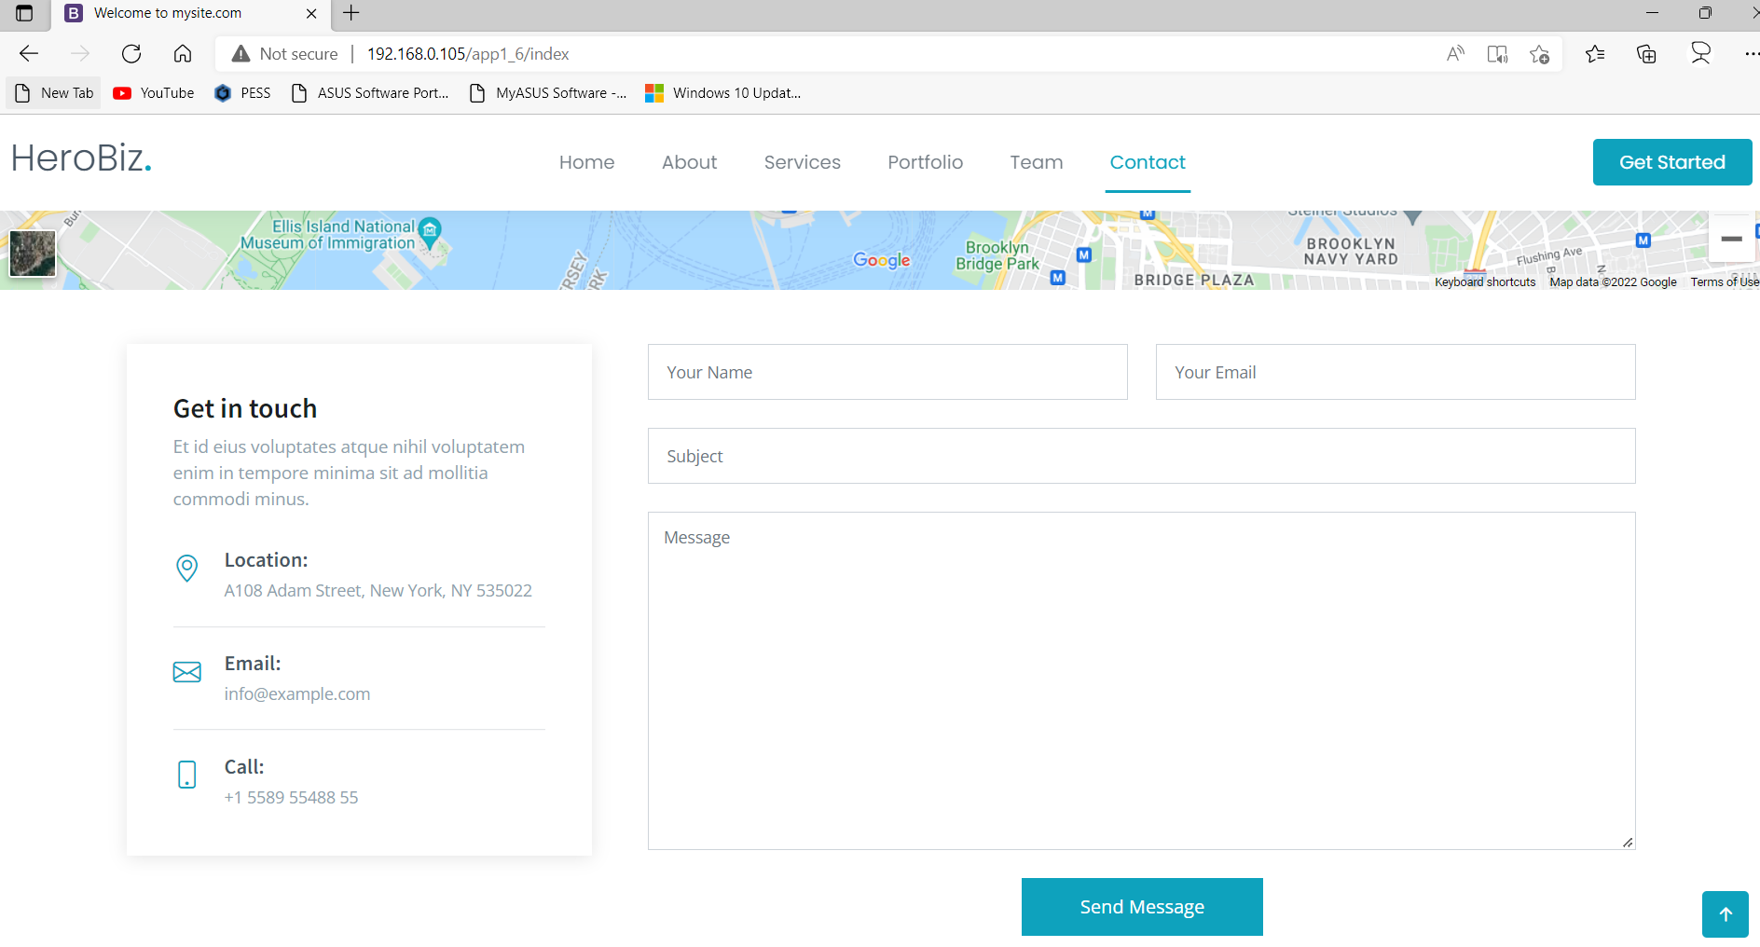

* Display all the saved contact details from database/text file.

**Task 7:**

* Email Subscribe

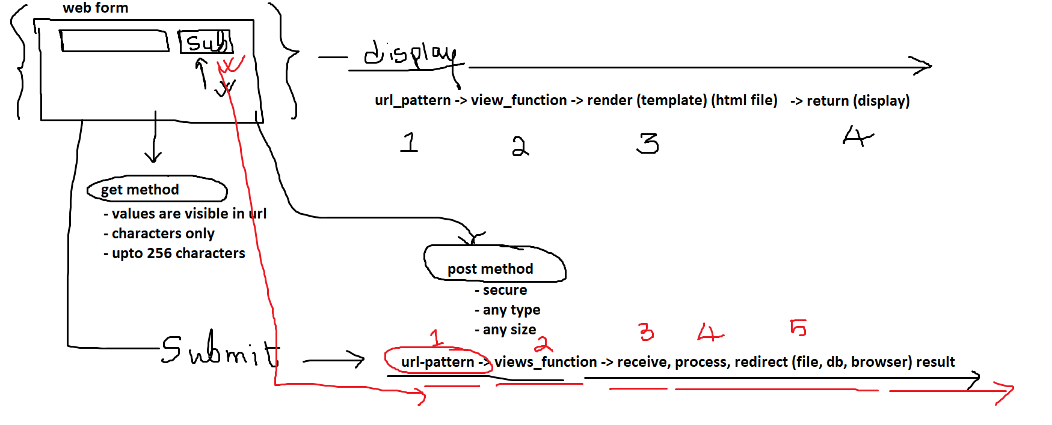

**12.c** Create **ePanel** (app1_9) to retrieve **subscribing emails** and visitor **comments**.

* Create and register new app (**app1_9**)
* Create views function and url pattern to show **subscribing emails**
* Update on root\**urls.py**
* Browse the site
* Get all emails form database
* Send emails to template to display
* Display emails in template
* Browse the site

**Task 8:** After sending subscribing email visitor will get subscribing successful message as popup and redirect to index page of site.

**13. Database**

**13.a. Database Connectivity using Django**

* root\**settings.py**

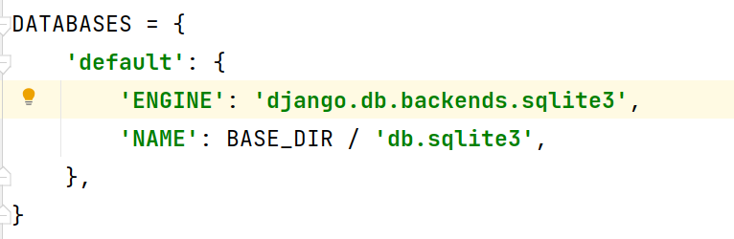

* Migrate default database tables on database
* **python manage.py migrate** # Create default tables and insert default values

**13.2. Create super user (Super Administrator) (for Admin Site)**

**python manage.py createsuperuser**

Username (leave blank to use 'asus'): **admin**

Email address: **admin@gmail.com**

Password: ***

Password (again): ***

The password is too similar to the username.

This password is too short. It must contain at least 8 characters.

This password is too common.

Bypass password validation and create user anyway? [y/N]: **y**

**13.3. Login Admin Site**

* **http://192.168.0.105/admin**
* User Name: **admin**
* Password: **admin**
* Click on **Login** Button
* Admin Panel Dashboard

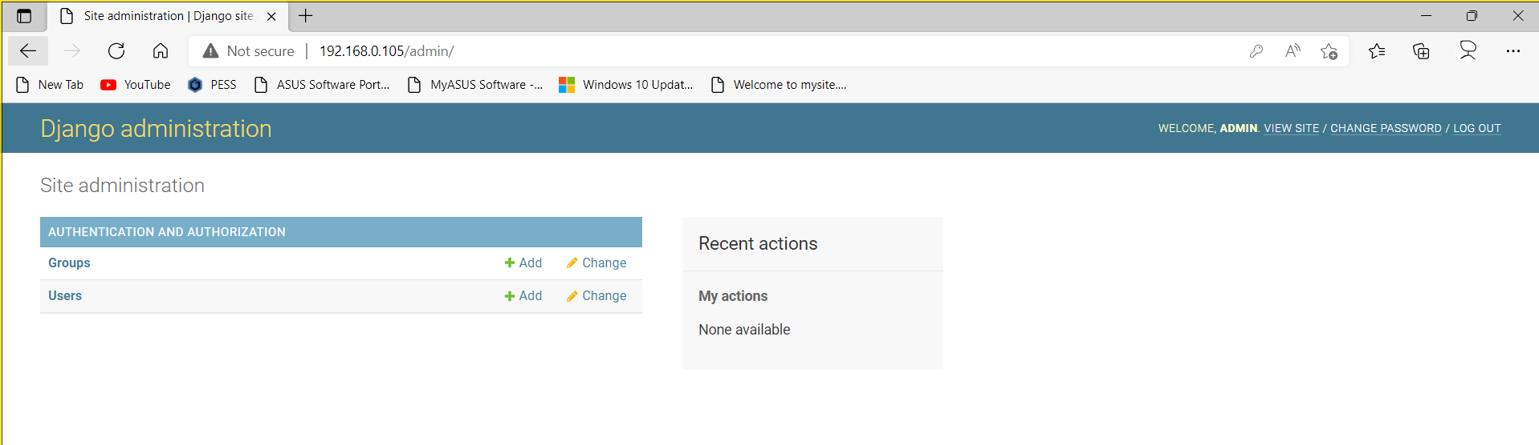

**14. Model**

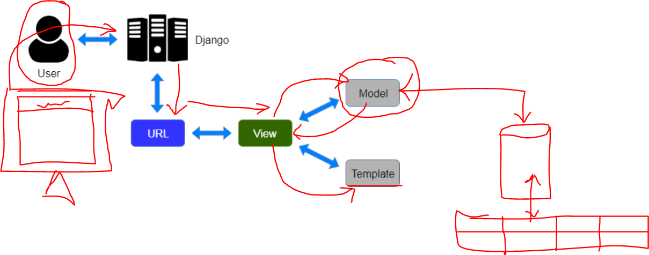

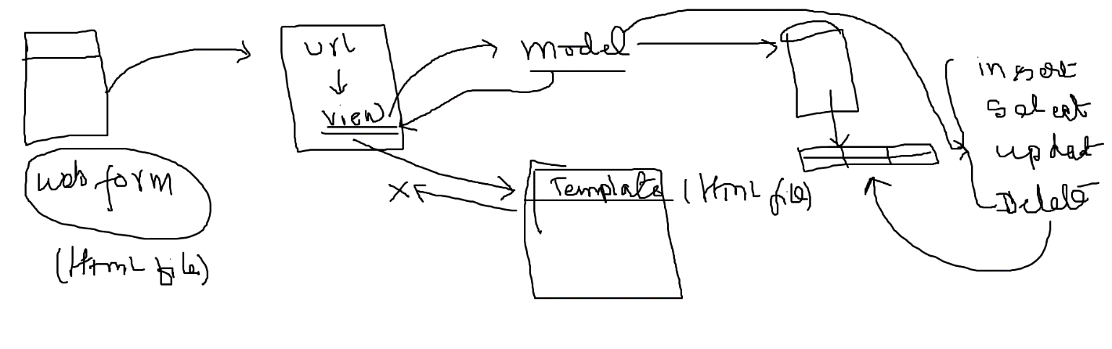

**14.a Creating new Model**

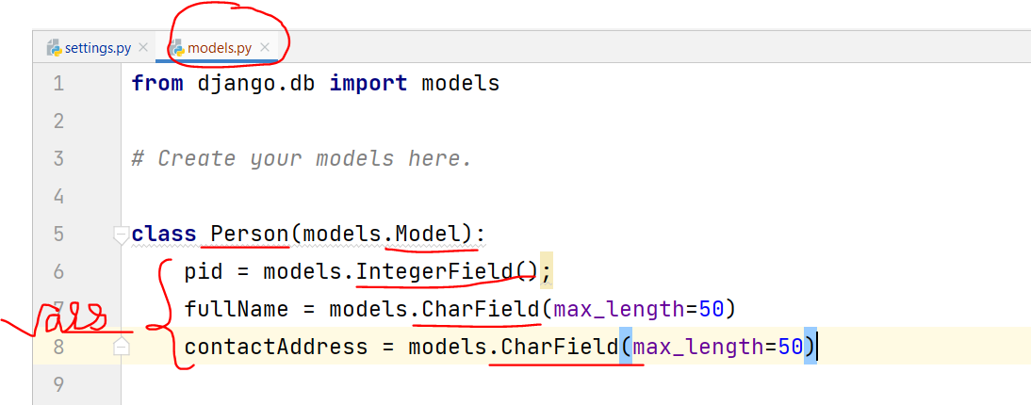

**14.b Make Migrations and Migrate Model**

* python manage.py makemigrations # Create DDL
* python manage.py migrate # Execute DDL

**14.c Register Existing Model on Admin Panel**

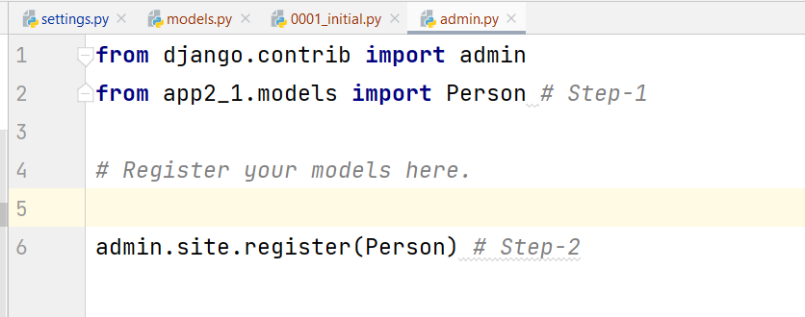

**14.d CRUD using Model**

**Insert New Record  
Step-1**p1 = Person2()  
p1.pid=1  
p1.fullName="Jatin Singh"  
p1.contactAddress="KTM"  
p1.save()  
  
**Step-2**p2 = Person2(pid=2, fullName='John Bista', contactAddress='LAT')  
p2.save()  
  
**Select all Records**  
countries = Country.objects.all() # all records  
for country in countries:  
 print(country)  
  
**Filter/Search Record**  
countries = Country.objects.filter(country='Nepal')  
countries = Country.objects.filter(country='India')  
countries = Country.objects.filter(country__startswith='M')  
for country in countries:  
 print(country)  
 **Update Record**  
p1 = Person2.objects.get(pid=2)  
print(p1) # 2, John Bista, LAT  
p1.contactAddress="Lalitpur"  
p1.save()  
p1 = Person2.objects.get(pid=2)  
print(p1) # 2, John Bista, Lalitpur  
  
**Delete Record**p1 = Person2.objects.get(pid=1)  
p1.delete()

**14.e CRUD Application-1**

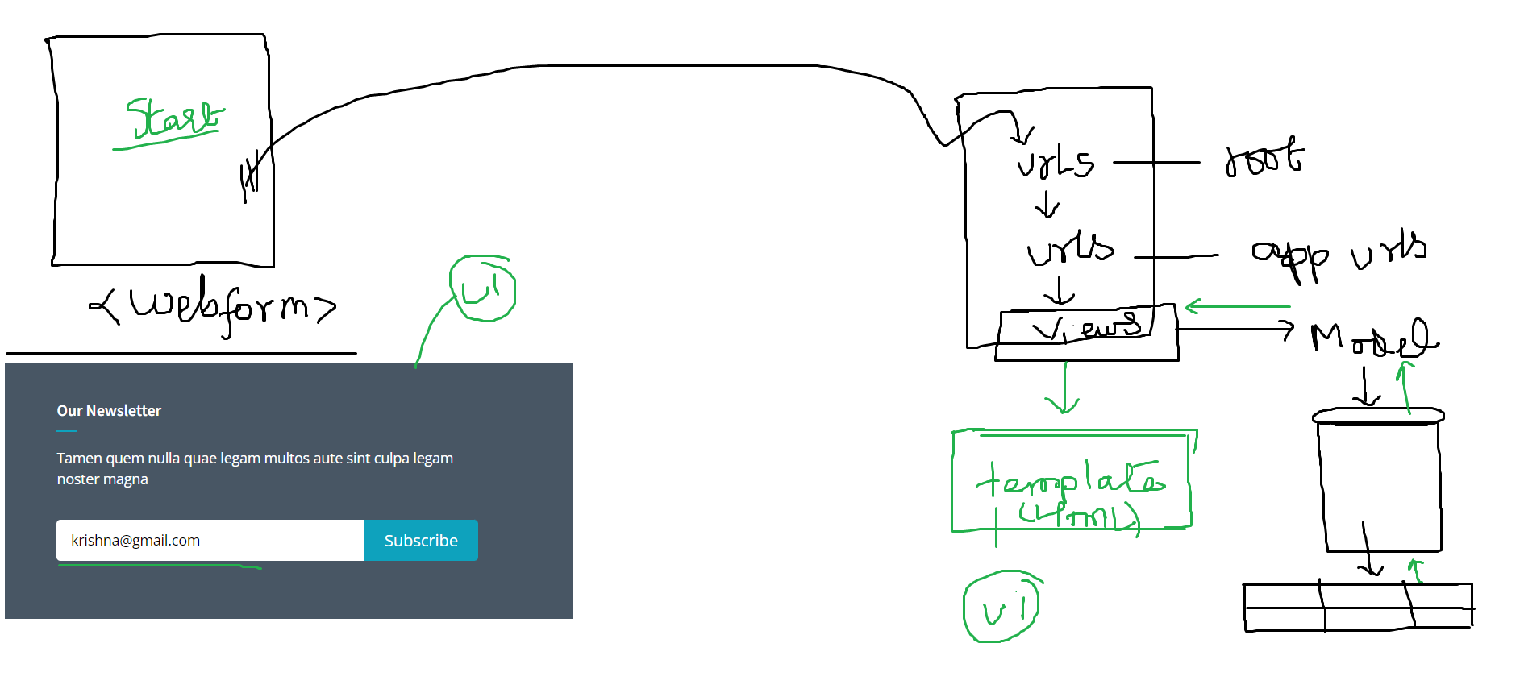

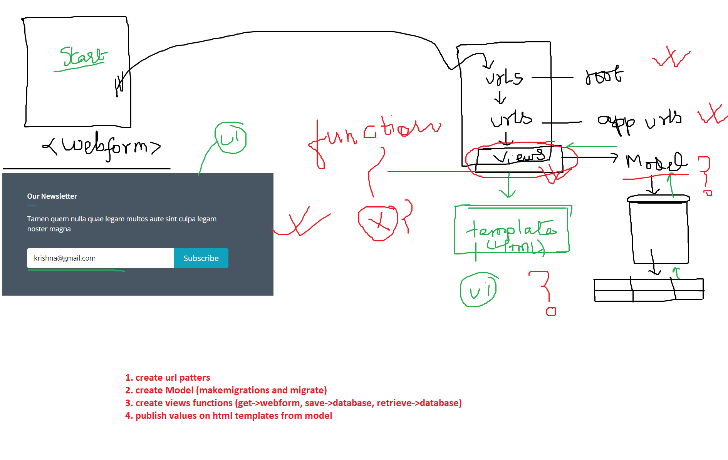

**Solution:**

**1. URL Patterns**

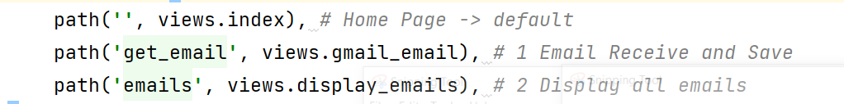

**2. Create a Model**

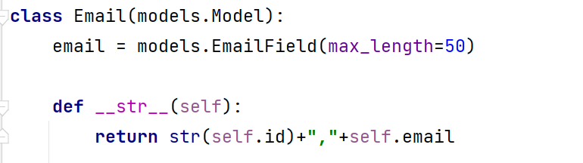

**3. Create views function**

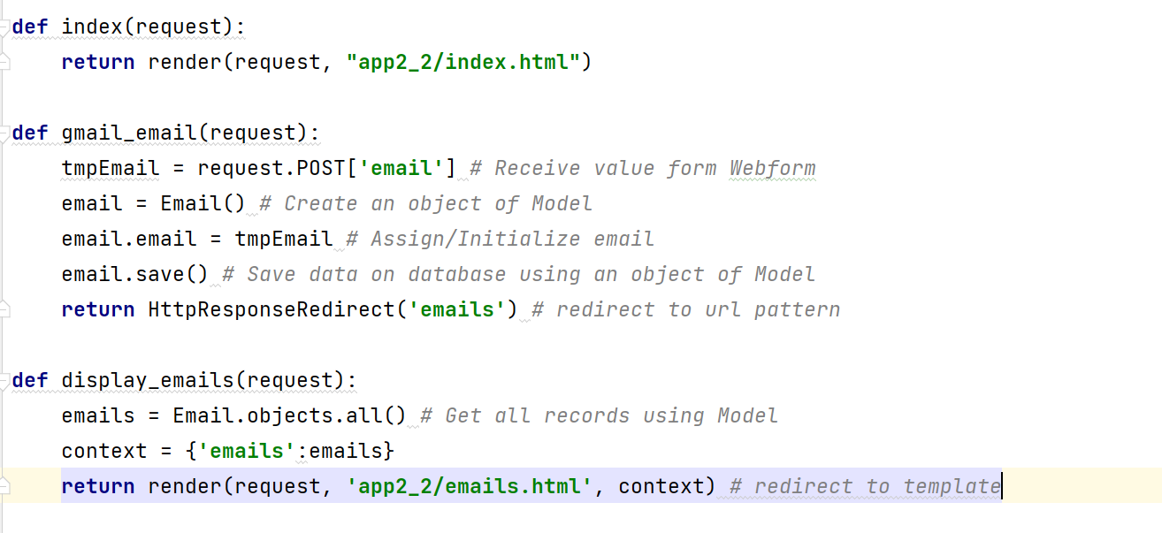

**4. Create Templates**

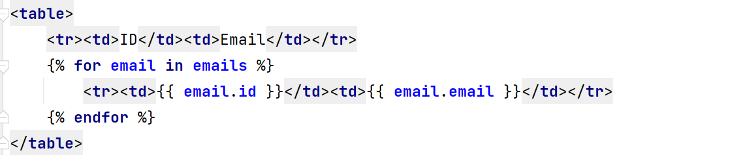

**5.** **Integrate**

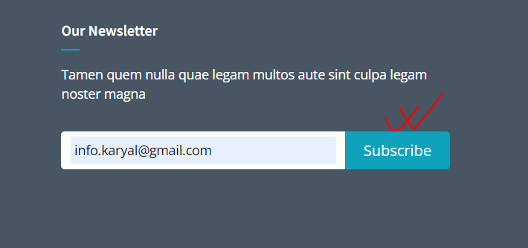

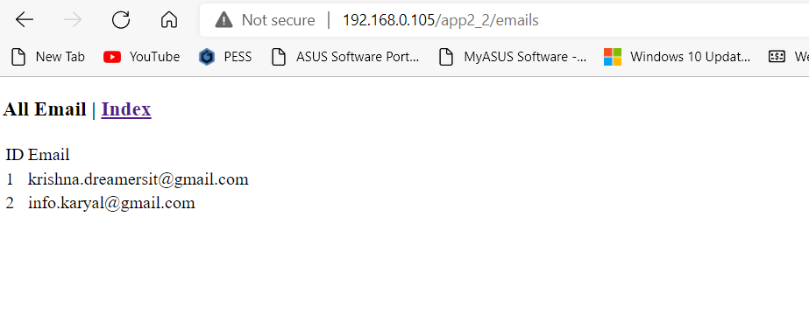

**Task9: Create CRUD application using Model.**

* Add new record (with alert – insert record successfully)
* Display all records
* Search record (with alert – search record successfully)
* Edit record (with alert – update record successfully)
* Delete record (with alert – delete record successfully)
* Export record (s) (xls, xml, txt, csv)

**Note:**

* HTML, CSS, JavaScript